**Hardy Nutritionals**

**A Project Report Submitted In Partial Fulfillment of the Requirements for The Degree of**

**MASTER OF COMPUTER APPLICATION**

**by**

**Akash Dixit**

**(Roll no.: 1900290149008)**

**Under the supervision of**

**Dr. Sangeeta Arora**

**Associate Professor**

## KIET GROUP OF INSTITUTIONS, GHAZIABAD



**to the**

**DEPARTMENT OF COMPUTER APPLICATIONS**

**DR. A.P.J. ABDUL KALAM TECHNICAL UNIVERSITY LUCKNOW**

**(Formerly Uttar Pradesh Technical University, Lucknow)**

**August 2021**

# **DECLARATION**

I hereby declare that this submission is my own work and that, to the best of my knowledge and belief, it contains no material previously published or written by another person nor material which to substantial extent has been accepted for the award of any degree or diploma of the university or another institute of higher learning except where due acknowledgment has been made in the text.

Name: Akash Dixit

Roll No: 1900290149008

Signature:

# **CERTIFICATE**

Certified that **Akash Dixit (1900290149008)** has carried out the project work presented in this project entitled **“Hardy Nutritionals”** for the award of **Master of Computer Application** from Dr. A.P.J Abdul Kalam Technical University, Lucknow under my supervision. The thesis embodies results of original work, and studies as are carried out by the student himself and the contents of the thesis do not form the basis for the award of any other degree to the candidate or to anybody else from this or any other University/Institution.

**Dr. Sangeeta Arora External Examiner**

Associate Professor

Department of Computer Applications

KIET Group of Institutions, Ghaziabad

### **Dr. Ajay Kumar Shrivastava**

Prof. & Head of

Department of Computer Application

KIET Group of Institutions,

Ghaziabad

Date:

# **HARDY NUTRITIONALS AKASH DIXIT**

# **ABSTRACT**

Micronutrients are one of the major groups of nutrients your body needs. They include vitamins and minerals. Vitamins are necessary for energy production, immune function, blood clotting and other functions. Meanwhile, minerals play an important role in growth, bone health, fluid balance and several other processes.

This article provides a detailed overview of micronutrients, their functions and implications of excess consumption or deficiency. Vitamins are organic compounds made by plants and animals which can be broken down by heat, acid or air. On the other hand, minerals are inorganic, exist in soil or water and cannot be broken down. When you eat, you consume the vitamins that plants and animals created or the minerals they absorbed.

The micronutrient content of each food is different, so it’s best to eat a variety of foods to get enough vitamins and minerals.



Date: 02nd August 2021

**INTERNSHIP CERTIFICATE**

TO WHOM IT MAY CONCERN

This is to certify that Mr. Akash Dixit, MCA student from KIET Group of Institution, Ghaziabad, was working as an Intern (From 1st December’2020 – 31st May’2021) at Ksolves India Ltd.

During this period, he has been given exposure and training on the technology “Ruby on Rails” and have worked on a live project.

Further, we found him sincere, hardworking, technically sound and result oriented.

Akanksha Saini

Senior HR Manager

@Ksolves India Limited

## ACKNOWLEDGEMENTS

Firstly, I thank **KSOLVES INDIA LIMITED** for allowing me to complete my

successfully. I express my sincere gratitude to all those who initiated and helped me in the successful completion of this project. Sincere thanks and profound gratitude to my project Manager **Mr. Atul Khanduri** for their strict supervision, constant encouragement, inspiration and guidance, which ensure the worthiness of my work. Working under them was an enrich experience and my project Internal Supervisor **Dr. Sangeeta Arora** for helping in carrying out the project work and for many valuable and useful information and guidance while bringing out this project.

I am highly grateful to **Dr. Ajay Kumar Shrivastava**, **HOD** of **MCA** KIET Group Of Institutions, Ghaziabad for providing this opportunity to carry out the Major Project at **“HARDY NUTRITIONALS”**. KIET Group Of Institutions Ghaziabad for providing academic inputs, guidance & Encouragement throughout this period.

Finally, I express my indebtedness to all who have directly or indirectly contributed to the successful completion of my major project.

Akash Dixit

**1900290149008**

# **TABLE OF CONTENTS**

Page No.

Declaration……………………………………………………………..ii

Certificate…………………………………………………………………….iii

Abstract………………………………………………………………………iv

Acknowledgement……………………………………………………………iv

Table of Contents…………………………………………………………….vi

List of Figures………………………………………………………………...x

List of Abbreviations………………………………………………………...vii

**CHAPTER 1: Literature Review ..................................................... 15**

1.1 Hardy Nutritionals……….. ............................................................. 15

1.2 Market Research .............................................................................. 15

1.3 Sampling .......................................................................................... 16

1.4 Testing.............................................................................................. 16

1.5 Monitoring ....................................................................................... 17

**CHAPTER 2: INTRODUCTION …………………………………18**

2.1 Hardy Nutritionals Introduction ……............................................18

2.2 Market Research Introduction .......................................................18

2.3 Security and its Significance .........................................................19

2.4 Implementation of Market Research .............................................19

2.4.1 Swot Analysis ............................................................................ 19

2.5 Technical Background ..................................................................20

2.5.1 Classical Market Techniques…............................................. 20

2.5.2 The Market Standard (Des) ...................................................21

2.5.3 The Advanced Market Standard (Aes) ................................. 22

**CHAPTER 3**: **BUSSINESS RESEARCH. ....................................23**

3.1 Problem description………………………………………..23

3.2 Significance of Market Research………………………….24

3.2.1 Market Research ........................................................24

3.2.2 Hill Cipher ................................................................25

3.2.3 Research and market sectors ....................................25

3.2.4 Influence from Internet ...........................................26

3.2.5 Research and social media applications ........................... .27

3.2.6 International plan ........................................................... 28

3.3 Testing and comparative analysis ............................................... 28

**CHAPTER 4: TOOLS…………………………………….……….30**

4.1 Packages… .................................................................................... 30

4.2 Methods ........................................................................................ .30

4.3 Premium pricing............................................................................. 31

**CHAPTER 5: CONFIGURE RAILS……………………….…….32**

5.1 Dashboard .................................................................................... .32

**CHAPTER 6: Creation of a Draft………………………………….33**

6.1 Project Settings… .......................................................................... 33

6.2 Creation of a Target Group ............................................................ 34

6.2.1 Basic Settings ....................................................................... 34

6.2.2 Regions .................................................................................. 35

6.2.3 Supply ................................................................................... 35

6.2.3.1 Ad-Hoc supply ............................................................ 36

6.2.4 Profiling ................................................................................. 36

6.2.4.1 Profiling logic ................................................................ 36

6.2.4.2 Profiling depth and cross profiling ...........................37

6.2.4.3 Panel Quality .............................................................. 37

6.3 Quotas .......................................................................................... 38

6.4 Interlocks ...................................................................................... 44

6.5 Exclusions ..................................................................................... 46

6.5.1 Automatic Exclusions… ...................................................... 48

6.5.2 Project Exclusions… ........................................................... 49

6.5.3 Panelist Exclusions .............................................................. 50

6.6 Naming Of TGs… ........................................................................ 51

**CHAPTER 7: Creating a New Rails App……………..………….52**

7.1 PM Tool Terms and Conditions .................................................... 52

7.1.1 Splitting a job over multiple PM Tool project ...................... 53

7.2 Optional tags ................................................................................ 54

7.3 Panel Questions And Answers tags ............................................. 55

7.4 Non-dynamic parameters… ......................................................... 56

7.5 Test link and instructions… ......................................................... 57

7.5.1 Screening information .........................................................58

7.5.2 Testing a survey ................................................................... 58

7.6 Redirects… ................................................................................... 62

7.6.1 Redirects for external Sample Only clients… ..................... 63

7.6.2 KSolves India LImited and Internally Scripted clients………63

**CHAPTER 8: Project Delivery…………………………………….64**

8.1 PM Tool Data ................................................................................. 64

8.2 Project Management and Monitoring .............................................. 65

8.3 Managing Tenure ............................................................................. 66

8.4 Starting fieldwork ............................................................................ 67

8.5 Invitations…..................................................................................... 68

8.5.1 Customizing invitations… ................................................ .68

8.6 Optimizer ........................................................................................ .69

8.7 Closing fieldwork ............................................................................ 70

8.7.1 Close Quotas ...................................................................... 71

8.7.2 Update respondent statuses ................................................ 71

8.8 Closing Project ................................................................................. 72

8.9 Download Background Data ............................................................ 77

**CHAPTER 9: Supply…………………………………………….….79**

9.1 Usage of integrated partners as Ad Hoc supply ............................. 79

9.2 Working with Ad Hoc supply ........................................................ 81

9.3 KSolves API project .................................................................... 82

**CHAPTER 10: Mainstream………………………………………….83**

10.1 System Limits… ............................................................................ 83

10.2 How to run: Trackers .................................................................... 84

10.3 Creation of Waves .......................................................................... 85

10.4 Eliminations ....................................................................... 86

10.5 IDs ....................................................................................... 87

**CHAPTER 11: Note on PII Collection……………………….………88.**

11.1 Hardy Nutritionals Testing............................................................88

**CHAPTER 12: Conclusion………………………….…………………89**

**REFERENCES………………………………………………………….90**

# **LIST OF FIGURES**

Fig.5.1 Dashboard............................................................................... 32

Fig.6.1 Project Settings.. .................................................................... 35

Fig.6.2 Supply.................................................................................... 37

Fig.6.3 Panel...................................................................................... 38

Fig.6.4 Depth..................................................................................... 40

Fig.6.5 Variety Score......................................................................... 41

Fig.6.6 Complete Level..................................................................... 42

Fig.6.7 Quotas................................................................................... 43

Fig.6.8 Interlocks.............................................................................. 44

Fig.6.9 SetQuotas............................................................................. 46

Fig.6.10 Exclusion........................................................................... 49

Fig.6.11 Panelist Exclusions............................................................ 50

Fig.7.1 Create Projecticon................................................................ 52

Fig.7.2 Summary............................................................................... 54

Fig.7.3 Surveylinksetup…................................................................. 55

Fig.7.4 Non-dynamic Parameters...................................................... 58

Fig.7.5 Live links............................................................................... 59

Fig. 7.6 Testing Links ………………………………………........... 61

Fig.8.1Projectoverview….................................................................. 65

Fig.8.2ProjectManagementandMonitoring….................................... 65

Fig. 8.3 Dashboard…………………………………………………..67

Fig 8.4.FAQs..................................................................................... 68

Fig.8.5SelectRelaxSub-Quotas ........................................................ 68

Fig.8.6SampleSetting…..................................................................... 69

Fig.8.7CollectCompletes.................................................................... 71

Fig.8.8Managesendouts.......................................................................72

Fig.8.9selecteditinvitationemai........................................................... 73

Fig. 8.10 DOTCOM Monitoring..........................................................75

Fig.8.11Close selected quotas and Save changes................................ 75

Fig.8.12 Update Responded Statement................................................ 76

Fig.8.13 A project that is closed cannot be reopened…....................... 77

Fig.8.14 Download Background Data................................................... 78

Fig.9.1 Select your supplier from the Ad Hoc supply setups.................. ...80

Fig. 9.2 Testing .......................................................................................... 81

Fig. 9.3 URL Grabber................................................................................. 82

Fig.9.4 Pass the Test and Live links to the supplier.................................... 83

Fig. 10.1 System Limits……………………………………………………84

### **LIST OF ABBREVIATIONS**

|  |  |
| --- | --- |
|  |  |
| MR | Market Research |
| CPI | Cost Per Interview |
| RIM | Random Iterative Method |
| GUI | Graphical User Interface |
| GUID | Globally Unique Identifier |
| LOI | Length Of Interview |
| IR | Incidence Rate |
| PO | Purchase Order |
| MAC NO. | Maconomy Number |

**CHAPTER 1**

**LITERATURE REVIEW**

### **1.1 Hardy Nutritionals**

Bellotti, V., & Smith [1] Initially, the system was conceived as a paper-based UI to calendar, contacts, to-dos and notes. As the micronutrient progressed, our understanding of peoples practices and the constraints of their office infrastructures radically shifted our design goals away from paper-based interaction to embedded interaction with our system.

Edmondson, A. C., & McManus [2] We introduce a contingency framework that

relates prior work to the design of a research project, paying particular attention to the question of when to mix qualitative and quantitative data in a single research paper. We discuss implications of the framework for educating new field researchers.

### **1.2 Market Research**

Rumelt, R. P., & Wensley [3] This paper reports on an empirical investigation of the causal structure underlying the association between market share and business profitability. The results suggest that such factors as scale economies and/or market power are much less important than stochastic growth processes.

Mortensen, D. T., & Pissarides [4] In this literature, unemployment spell and job spell durations as well as wage offers are treated as endogenous outcomes of forward looking job creation and job destruction decisions made by the workers and employers who populate the models.

Bar-Isaac, H., Caruana [5] 1We analyze the effect of reduced search costs, finding results consistent with the reported prevalence of niche goods and long-tail and superstar phenomena.

### **1.3 Sampling**

Taherdoost, H. [6] This paper presents the steps to go through to conduct sampling. Furthermore, as there are different types of sampling techniques/methods, researcher needs to understand the differences to select the proper sampling method for the research. In the regards, this paper also presents the different types of sampling techniques and methods.

Kalagnanam, J. R., & Diwekar, U. M.[7] The number of samples required to

converge to the mean and variance is used as a measure of performance.

### **1.4 Testing**

Madsen, H. S. [8] Techniques for developing the various kinds of exam questions

are covered in the activities section of each chapter.

Andrews, J. M., & BSAC [9] The method described here, like all other standardized methods of disc testing, cannot be adapted by the user, and interpretative criteria are only applicable if the method is adhered to fully.

Quellmalz, E. S., & Pellegrino, J. W. [10] Innovative applications of technology also provide rich, authentic tasks that challenge the sorts of integrated knowledge, critical thinking, and problem solving seldom well addressed in paper-based tests.

### **1.5 Monitoring**

Nichols, J. D., & Williams, B. K. [11] Many programs that are identified with the

purpose of ‗surveillance‘ represent an inefficient use of conservation funds and effort.

Lucas Jr, H. [12] Each of these techniques is rated on its suitability for the three purposes of evaluation. Recommendations are made on the most appropriate technique for each evaluation purpose.

Snyder, M. [13] Self-monitoring is the proposition that individuals can and should exercise control over their expressive behavior, self-presentation, and nonverbal displays of affect. Hellawell, J. M. [14] ‗Monitoring‘ has become an omnibus term and is sometimes

applied, almost indiscriminately, to a range of disparate activities.

**CHAPTER 2**

### **INTRODUCTION**

In this chapter we will give an introduction about security locks and protection on computer system. Here we also give an overview of how the data and file are encrypted and decrypted in system.

### **2.1 Hardy Nutritionals**

The project is based on **“Hardy Nutritionals”** it is a part of micronutrients which we discuss later briefly field research of fieldwork is the accumulation of the data outside a lab, library or working environment setting. The objectives of this system are:

* Health Management
* Daily Monitoring
* Time tracking
* Integrated invoicing/payment processing

### **2.2 MARKET RESEARCH**

**Marketing research** is "the process or set of processes that links the consumers, customers, and end users to the marketer through information — information used to identify and define marketing opportunities and problems; generate, refine, and evaluate marketing actions; monitor marketing performance; and improve understanding of marketing as a process. Marketing research specifies the information required to address these issues, designs the method for collecting information, manages and implements the data collection process, analyzes the results, and communicates the findings and their implications.

It is the systematic gathering, recording, and analysis of qualitative and quantitative

data about issues relating to marketing products and services. The goal of Marketing research is to identify and assess how changing elements of the marketing mix impacts customer behavior.

### **2.3 SECURITY AND ITS SIGNIFICANCE**

**Market research** is any organized effort to gather information about

target markets or customers. It is a very important component of business strategy. The term is commonly interchanged with **marketing research** however, expert practitioners may wish to draw a distinction, in that marketing research is concerned specifically about marketing processes, while market research is concerned specifically with markets.

Market research is a key factor in maintaining competitiveness over competitors. Market research provides important information to identify and analyze the market need, market size and competition.

Market research, which includes social and opinion research, is the systematic gathering and interpretation of information about individuals or organizations using statistical and analytical methods and techniques of the applied social sciences to gain insight or support decision making.

Market segmentation is the division of the market or population into subgroups with similar motivations. It is widely used for segmenting on geographic differences, personality differences, demographic differences, technographic differences, use of product differences.

### **2.4 IMPLEMENTATION OF MARKET RESEARCH**

#### **2.4.1 SWOT Analysis**

SWOT is a written analysis of the **Strengths, Weaknesses, Opportunities and Threats** to a business entity. Not only should a SWOT be used in the creation stage of the company but could also be used throughout the life of the company. A SWOT may also be written up for the competition to understand how to develop the marketing and product mixes.

Another factor that can be measured is marketing effectiveness. This includes:

2.4.1.1 Customer analysis

2.4.1.2 Choice modeling

2.4.1.3 Competitor analysis

2.4.1.4 Risk analysis

2.4.1.5 Product research

2.4.1.6 Advertising the research

2.4.1.7 Marketing mix modeling

2.4.1.8 Simulated Test Marketing

### **2.5 TECHNICAL BACKGROUND**

#### **2.5.1 Classical Market Techniques**

It is important to test marketing material for films to see how an audience

will receive it. There are several market research practices that may be used:

2.5.1.1 Concept testing, which evaluates reactions to a film idea and is fairly rare;

2.5.1.2 Positioning studios, which analyze a script for marketing opportunities;

2.5.1.3 Focus groups, which probe viewers' opinions about a film in small groups prior to release;

2.5.1.4 Test screenings, which involve the previewing of films prior to theatrical release;

2.5.1.5 Tracking studies, which gauge (often by telephone polling) an audience's awareness of a film on a weekly basis prior to and during theatrical release;

2.5.1.6 Advertising testing, which measures responses to marketing materials such as trailers and television advertisements; and finally

2.5.1.7 Exit surveys, that measure audience reactions after seeing the film in the cinema.

**Monoalphabetic Cipher**: From the marketer's point of view, an **efficient price** is a price that is very close to the maximum that customers are prepared to pay. In economic terms, it is a price that shifts most of the consumer economic surplus to the producer. A good pricing strategy would be the one which could balance between the price floor (the price below which the organization ends up in losses) and the price ceiling (the price be which the organization experiences a no-demand situation)

**Pricing**: The price/quality relationship refers to the perception by most consumers that a relatively high price is a sign of good quality. The belief in this relationship is most important with complex products that are hard to test, and experiential products that cannot be tested until used (such as most services). The greater the uncertainty surrounding a product, the more consumers depend on the price/quality hypothesis and the greater premium they are prepared to pay. The classic example is the pricing of Twinkies, a snack cake which was viewed as low quality after the price was lowered. Excessive reliance on the price/quality relationship by consumers may lead to an increase in prices on all products and services, even those of low quality, which causes the price/quality relationship to no longer apply .

#### 2.5.2 The Market Standard (Des)

Market trends are the upward or downward movement of a market, during a period of time. Determining the market size may be more difficult if one is starting with a new innovation. In this case, you will have to derive the figures from the number of potential customers, or customer segments.

Market segmentation is the division of the market or population into subgroups with similar motivations. It is widely used for segmenting on geographic differences, personality differences, demogra differences, technographic differences, use of product differences, psychographic differences and gender differences. For B2B segmentation firmographics is commonly used.

#### **2.5.3 The Advanced Market Standard (Aes)**

The task of marketing research (MR) is to provide management with relevant, accurate, reliable, valid, and current information. Competitive marketing environment and the ever-increasing costs attributed to poor decision making require that marketing research provide sound information. Sound decisions are not based on gut feeling, intuition, or even pure judgment.

**CHAPTER 3**

### **BUSINESS RESEARCH**

Market research is broader in scope and examines all aspects of a business environment. It asks questions about competitors, market structure, government regulations, economic trends, technological advances, and numerous other factors that make up the business environment (see environmental scanning). Sometimes the term refers more particularly to the financial analysis of companies, industries, or sectors. In this case, financial analysts usually carry out the research and provide the results to investment advisors and potential investors.

**Product research** — This looks at what products can be produced with available technology, and what new product innovations near-future technology can develop (see new product development).

**Advertising research** - is a specialized form of marketing research conducted to improve the efficacy of advertising. Copy testing, also known as "pre-testing," is a form of customized research that predicts in-market performance of an ad before it airs, by analyzing audience levels of attention, brand linkage, motivation, entertainment.

### **3.1 PROBLEM DESCRIPTION**

Business to business (B2B) research is inevitably more complicated than consumer research. The researchers need to know what type of multi-faceted approach will answer the objectives, since seldom is it possible to find the answers using just one method. Finding the right respondents is crucial in B2B research since they are often busy, and may not want to participate. Encouraging them to ―open up‖ is yet another skill required of the B2B researcher. Last, but not least, most business research leads to strategic decisions and this means that the business researcher must have expertise in developing strategies that are strongly rooted in the research findings and acceptable to the client.

* There are four key factors that make B2B market research special and different from consumer markets:
* The decision making unit is far more complex in B2B markets than in consumer markets.
* B2B products and their applications are more complex than consumer products.
* B2B marketers address a much smaller number of customers who are very much larger in their consumption of products than is the case in consumer markets.
* Personal relationships are of critical importance in B2B markets.

### **3.2 SPECIFICATION OF MARKET TECHNIQUES**

**Marketing research** does not only occur in huge corporations with many employees and a large budget. Marketing information can be derived by observing the environment of their location and the competitions location. Small scale surveys and focus groups are low cost ways to gather information from potential and existing customers. Most secondary data (statistics, demographics, etc.) is available to the public in libraries or on the internet and can be easily accessed by a small business owner.

Below are some steps that could be done by SME (Small Medium Enterprise) to analyze the market:

3.2.1 Provide secondary and or primary data (if necessary);

3.2.2 Analyze Macro & Micro Economic data (e.g. Supply & Demand, GDP, Price change, Economic growth, Sales by sector/industries, interest rate, number of investment/ divestment, I/O, CPI, Social analysis, etc.);

3.2.3 Implement the marketing mix concept, which is consist of: Place, Price, Product, Promotion, People, Process, Physical Evidence and also Political & social situation to analyze global market situation);

3.2.4 Analyze market trends, growth, market size, market share, market competition (e.g. SWOT analysis, B/C Analysis, channel mapping identities of key channels, drivers of customer‘s loyalty and satisfaction, brand perception, satisfaction levels, current competitor-channel relationship analysis, etc.);

3.2.5 Determine market segment, market target, market forecast and market position;

3.2.6 Formulating market strategy & also investigating the possibility of partnership/ collaboration (e.g. Profiling & SWOT analysis of potential partners, evaluating business partnership.

#### **3.2.1 MARKET RESEARCH**

The primary online sale providers in B2C E-Commerce, worldwide, includes the USA based organisation. which remains the E-Commerce revenues, global leader. The growth leaders in the world top ten are two online companies from China, both of which conducted some organisation this year; Alibaba Group Holding Ltd. and JD Inc. Another company from the top ten is Cnova N.V., a recently formed Ecommerce subsidiary of the French Group Casino, with various store retailers developing and expanding their E-Commerce facilities worldwide. It is a further indication of how consumers are increasingly being attracted to the opportunities of online researching and expanding their awareness of what is available to them.

Service providers; for example, those related to finance, foreign market trade and investment promote a variety of information and research opportunities to online users. In addition, they provide comprehensive and competitive strategies with market research tools, designed to promote worldwide business opportunities for entrepreneurs and established providers. General access, to accurate and supported market research facilities, is a critical aspect of business development and success today. The Marketing Research Association was founded in 1957 and is recognized as one of the leading and prominent associations in the opinion and marketing research profession. It serves the purpose of providing insights and intelligence that helps businesses make decisions regarding the provision of products and services to consumers and industries.

#### **3.2.2 Hill Cipher**

The vendors are the third party sample sources which help us achieving the target numbers of the project, when our sample is exhausted. Alike we are the sample providers; we have many other companies who provide their sample/panelists for a particular project. They follow the same process, which we follow with our client i.e. costing of the project, providing the end pages, implementation of links, testing feedback and then fieldwork management.

Every company has its own policies of panelist management and their own way of capturing the panelist ids through their end pages. End pages would be generic or unique depending upon their policy. It entirely is the process through which both vendor and we capture the panelists in the correct form. The first and foremost step is to implement the provided end pages in PM Tool for the particular study number.

#### **3.2.3 Research and market sectors**

This organization knowledge of market conditions and competition is gained by researching relevant sectors, which provide advantages for entry into new and established industries. It enables effective strategies to be implemented; the assessment of global environments in the service sectors, as well as foreign market trade and investment barriers! Research, is utilized for promoting export opportunities and inward investment, helping determine how to execute competitive strategies, focus on objective policies and strengthen global opportunities. It is a medium that influences, administrates and enforces agreements, preferences, leveling trading environments and competitiveness in the international marketplace.

The retail industry aspect of online market research, is being transformed worldwide by M-Commerce with its mobile audience, rapidly increasing as the volume and varieties of products purchased on the mobile medium, increases. Researchers conducted in the markets.

#### **3.2.4 Influence from the Internet**

The availability of research by way of the Internet has influenced a vast number of consumers using this media; for gaining knowledge relating to virtually every type of available product and service. It has been added to by the growth factor of emerging global markets, such as China, Indonesia and Russia, which is significantly exceeding that of the established and more advanced B2C E-Commerce markets. Various statistics show that the increasing demands of consumers are reflected not only in the wide and varied range of general Internet researching applications, but in online shopping research penetration.

This is stimulated by product-enhancing websites, graphics, and content designed to attract casual "surfing" shoppers, researching for their particular needs, competitive prices and quality. According to the Small Business Administration(SBA), a successful business is significantly contributed to by gaining knowledge about customers, competitors, and the associated industry. Market research creates not only this understanding, but is the process of data analysis regarding which products and services are in demand.

The convenience and easy accessibility of the Internet has created a global B2C E-commerce research facility, for a vast online shopping network that has motivated retail markets in developed countries. In 2010, between $400 billion and $600 billion in revenue was generated by this medium also, it is anticipated that in 2015, this online market will generate revenue between $700 billion and $950 billion. The influence of market research, irrespective of what form it takes, is an extremely powerful incentive for any type of consumer and their providers!

#### **3.2.5 Research and social media applications**

The UK Market Research Society (MRS) reports research has shown that on average, the three social media platforms primarily used by millionaires, are LinkedIn, Facebook and YouTube. Social Media applications, according to T Systems, help generate the B2B E-commerce market and develop electronic business process efficiency. This application is a highly effective vehicle for market research, which combined with E- commerce, is now regarded as a separate, extremely profitable field of global business. While many B2B business models are being updated, the various advantages and benefits offered by Social Media platforms are being integrated within them.

Business intelligence organization have compiled a comprehensive report related to global online retail sales, defining continued growth patterns and trends in the industry. Headed ―Global B2C E-Commerce and Online Payment Market 2014‖ the report perceives a decrease in overall growth rates in North America and Western Europe, as the expected growth in the online market sales, is absorbed into the emerging markets. It is forecast that the Asia-Pacific region will see the fastest growth in the B2C E-Commerce market and replace North America.

#### 3.2.6 International plan

It is important to test marketing material for films to see how an audience

will receive it. There are several market research practices that may be used:

testing, which Concept evaluates reactions to a film idea and is fairly rare;

3.2.6.1 Positioning studios, which analyze a script for marketing opportunities;

3.2.6.2 Focus groups, which probe viewers' opinions about a film in small groups prior to release;

3.2.6.3 Test screenings, which involve the previewing of films prior to theatrical release;

3.2.6.4 Tracking studies, which gauge (often by telephone polling) an audience's awareness of a film on a weekly basis prior to and during theatrical release;

3.2.6.5 Advertising testing, which measures responses to marketing materials such as trailers and television advertisements; and finally.

3.2.6.6 Exit surveys, that measure audience reactions after seeing the film in the cinema.

### **3.3 TESTING AND COMPARATIVE ANALYSIS**

Market research is a way of getting an overview of consumers' wants, needs and beliefs. It can also involve discovering how they act. The research can be used to determine how a product could be marketed. Peter Drucker believed market research to be the quintessence of marketing.

There are two major types of market research. Primary Research sub-divided

into Quantitative and Qualitative research and Secondary research.

Through Market information one can know the prices of different commodities in the market, as well as the supply and demand situation. Market researchers have a wider role than previously recognized by helping their clients to understand social, technical.

**CHAPTER 4**

### **TOOLS**

Market Algorithm is developed in **HTML/PHP** programming language.

The packages and methods that are used in this algorithm are described below-

### **4.1 PACKAGES**

PM Tool is the in-house technical tool It was created with a thought of programming although with the time passed by, more options were added to make PM Tool as widely used tool for users.

What makes PM Tool unique from other technical tools is the user-friendly User Interface. It gives users, the whole variety to explore every bit of this tool to the core. Having all the qualities of a programming tool, PM Tool has been on the top list of users when it comes to sending invites to respondents, as it has been the only tool from where, any user could send invites. Running on HTML language, PM Tool brings so many variations to the programming world with its brilliant UI (User Interface) for daily work.

### **4.2 METHODS**

1. Link Setup
2. Testing.
3. Sending sample
4. Monitoring
5. Vendor setup
6. Final ids

### **4.3 Premium pricing**

Premium pricing (also called prestige pricing) is the strategy of consistently pricing at, or near, the high end of the possible price range to help attract statusconscious consumers. The high pricing of premium product is used to enhance and reinforce a product's luxury image. Examples of companies which partake in premium pricing in the marketplace include Rolex and Bentley. As well as brand, product attributes such as eco- labelling and provenance (e.g. 'certified organic' and 'product of Australia') may add value for consumers and attract premium pricing. A component of such premiums may reflect the increased cost of production. People will buy a premium priced product because:

They believe the high price is an indication of good quality.

They believe it to be a sign of self-worth - "They are worth it;" it authenticates the buyer's success and status; it is a signal to others that the owner is a member of an exclusive group; 

They require flawless performance in this application - The cost of product malfunction is too high to buy anything but the best - example: heart pacemaker.

**CHAPTER 5**

### **Login to PM Tool**

In order to log into PM Tool a user needs to go to PM Tool‘s web page at [www.PM Tool.com a](http://www.cint.com/)nd select the login button in the top right corner. Or alternatively to go directly to [https://login.PM Tool.com, t](https://login.cint.com/)hen enter the credentials of their account. Please be aware that both the username and the password are case sensitive and can consist of special characters.

In order to request a login an email needs to be sent to support@hardy. You will then receive an automated email from the PM Tool system requesting you to login and update your password.

If a created account is not used to log into PM Tool with for a 3-month period,

that login will be deleted and a new login will need to be requested.

### **5.1 Dashboard**

Once logged into PM Tool the main system dashboard appears. The dashboard consists of four separate tabs with navigation panels and five action buttons.

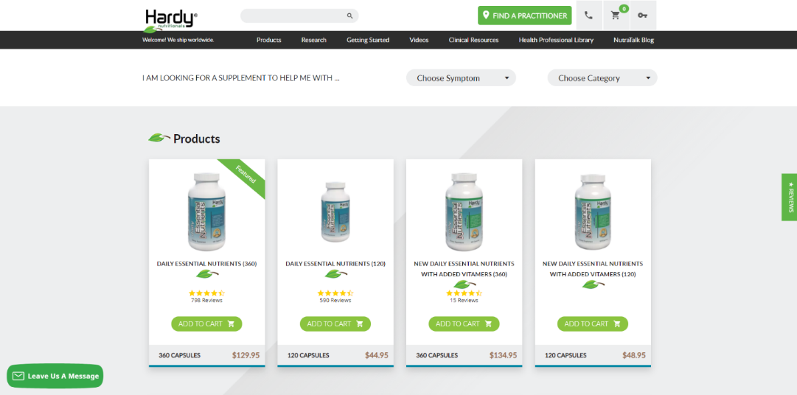

#### **Fig. 5.1 Home Page**

* **Idle** – this tab shows all projects that are in idle status. These projects have not registered any responded activity within the past 5 days.
* **Active** – this tab shows all projects that are active and collecting completes. Note that idle projects would also appear in this tab as well, colored in yellow.
* **Closed** – this tab shows all projects that have completed fieldwork and have been closed. Once a project form the Active/Idle tab is closed, it will move to the Closed tab.
* **Drafts** – this tab contains all saved project drafts/proposals created by sales. Operations will be able to find all proposals created by sales that are commissioned and need to be created as live projects. Drafts are kept by the system indefinitely, however if needed they can be manually deleted by selecting the bin icon.

Each tab contains a ―search field‖ where projects can be searched by Project ID or Draft ID, name or date. We will be able to search for projects by their Main Maconomy number due to our naming convention (see ―naming conventions‖).

**CHAPTER 6**

### **Creation of a Draft**

On the right hand side of the screen there is a button called **Create New Project** this button leads to the feasibility check and project ordering/setup. The initial purpose of a draft is to check feasibility on inserted specs, determine which supply sources we want to use and at which cost those supply sources can be commissioned.

The specs inserted into a draft will also be the basis on which a project is

created. Therefore, it is important that the draft reflects what we want to achieve during the project in as much detail as possible.

### **6.1 Project Settings**

The first screen to fill in is called **Project Settings**. Here we need to enter:

* **Survey categories**: Select one or more categories that most resembles the research topic. If sensitive topics are selected, such as Beverages – alcoholic or Smoking, Tobacco some supply sources might not be available for your study.
* **Survey**: Select the devices and technical requirements. These settings can be changed later, if necessary. Please note, that feasibility might be affected by these settings.
* **Respondents**: Geographical restriction ensures that panelists are physically located in the relevant survey country (via IP address). Preventing duplicates allows the system to detect and reject duplicates via a digital fingerprint.

In most cases, these settings should both be left on. However, when you will

intentionally be re-inviting panelists to the same study (for example during a recall or a recontact) Prevent Duplicates need to be set to NO.

* **Data collection**: If the survey collects PII (Personal Identifiable Information)

then select this setting. Some supply sources might not be available for studies collecting PII.

When PII collection is set to YES when we create a project out of the draft we will be asked to agree to additional terms and conditions.

Once we have finalized this information we click on ‗Continue‘ and flesh out our specifications further per target group.

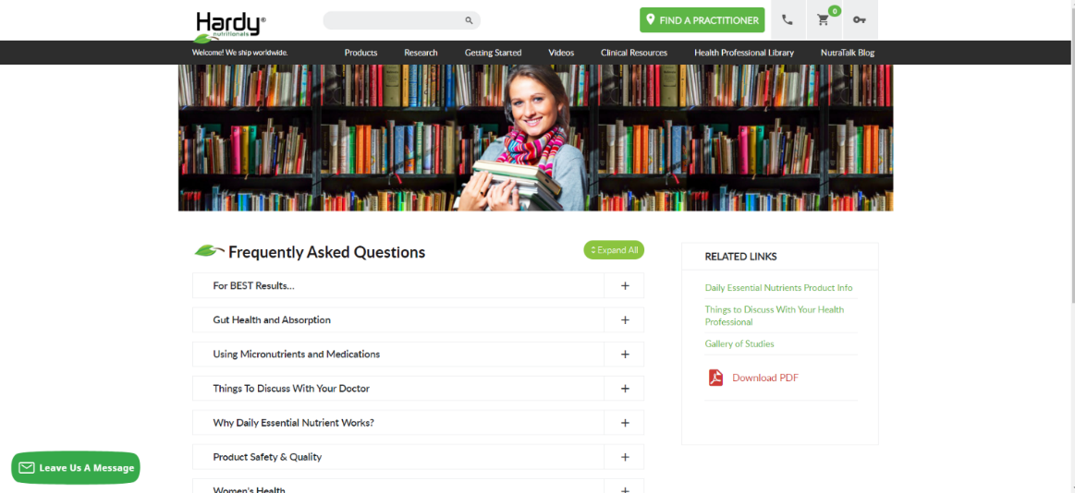

#### **Fig. 6.1 project faqs**

### **6.2 Creation of a Target Group**

The specification of a group of panelists you want to interview is called target

group. A project can have a minimum of 1 target group and maximum of 50.

It includes information such as the number of completed interviews wanted, the country from where people interviewed need to come from, the incidence rate, the length of the survey, the start and the end date of the fieldwork, the demographic criteria and the profile of the respondents that you wish to interview (smokers, car owners, mother of babies etc.).

A target group can have quotas, to distribute your interviews across different

demographics.

From your survey tool, you'll add survey links to the target group, the system

will use those to invite the selected panelists. If you need to set up multiple survey links, you will need to set up multiple target groups.

If the project includes multiple countries, each country will need to have a

separate target group.

The system will use your target group‘s definition to bring the right people

into the survey, therefore it's very important to define correctly the target group.

### **6.3 Basic Settings**

**Demographics**: Select the research market. Select the gender and ages (minimum and maximum age) of the target audience for this market. Please consider local legislation regarding child ages (for example for studies about alcoholic beverages).

Respondents younger than 14 years old are considered children and in case you need to contact this demographic group, you need to send your survey the parents of the children. A separate target group will need to be created for the parents that have children in the needed age range. When we send out to this target group, we will need to adjust the survey invitation mail (see ‗custom invitations‘) and the display text (see Portal data).

**Survey-specific data**: State the target number of completes and expected incidence rate and length of interview.

**Fixed LOI**: In markets where we have proprietary Parner Panel, we have the option to fix the LOI. If this is not ticked the incentives in field (and therefore our costs) will automatically be adjusted to the real LOI we register during fieldwork.

As Hardy Nutritionals best practice we should always tick it, and make changes like we do today, if they are significant and would affect the points, contact sales and make a decision to change it.

Based on international standards and on experience, PM Tool has implemented rules for minimum and maximum allowed length of interview (LOI) and incidence rate (IR). These are called country rules. Projects can be created only if they meet the minimum IR and the maximum LOI for each country (see Knowledge Base for most up-to-date limits). Projects only using LifePoints panels or Ad Hoc supply will always be allowed to be created.

**Start date** and **Number of days in field**: The number of days in field covers

both weekdays and weekends. The number of days in field can affect the feasibility for partner sample. You can extend the field time later, if needed. We cannot enter a fieldwork period longer than 31 days.

#### **6.3.1 Regions**

Allows users to make regional selections at sub-country level. Please note that

region granularity differs per market.

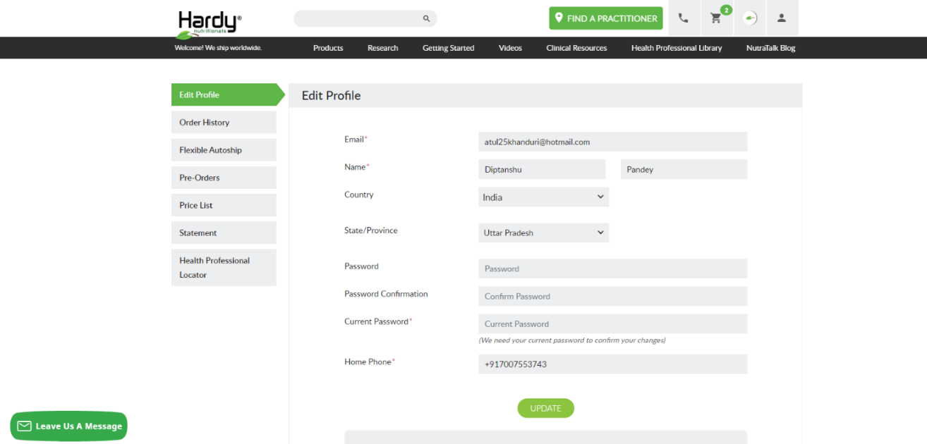

#### **Fig. 6.2 project profile**

Via the Regions section we can also upload a selection of postcodes to sample

on. Postcodes need to be uploaded in the correct formatting (a CSV. file in which they‘re sorted in ascending order with no duplicate values) in PM Tool. There might also be market specific rules in place on the postal code format itself. For example, in the UK

PM Tool accepts only the first part of the postcode for example ―NW1‖ and will not accept full UK postcodes as ―NW1 2SQ‖. PM Tool does not recognize any so- called

‗wildcards‘ (such as NW* or NW%).

Please note that in some markets where there‘s limited regional targeting

available, more regional profiling can be found under the ―Profiling‖ tab of PM Tool. Especially where holds very Hardy Nutritionals specific regional information, not part of the PM Tool Global profiling points.

If you need to create more than one regional group via postal code uploads,

you will need to set up each group within its own target group.

#### **6.3.2 Supply**

From this section the supply sources used in the target group can be selected.

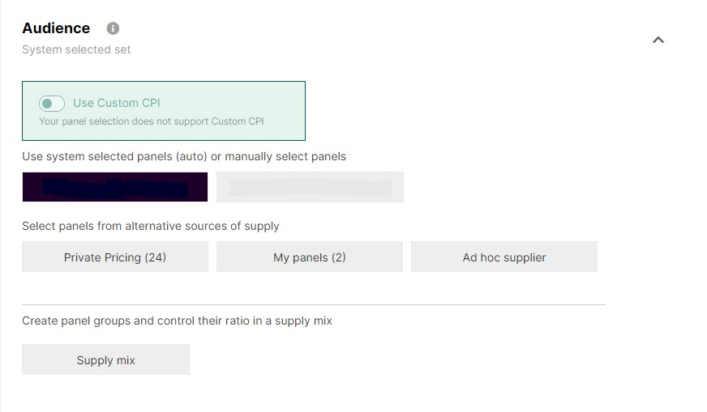

**Fig. 6.3 supply**

**Panels** – (Open Exchange) shows all panels from the PM Tool open exchange in the selected market. If no selection is made within the supply section, then all the panels will automatically be selected to provide panelists from. All partners in this section will have the same CPI.

**My Panels** – shows all Hardy Nutritionals owned panel assets in the selected market. This will show the LifePoints panels, All Global Circle panels and Vice Voices panels. **When we select our supply sources for a target group, we should always try to maximize our Hardy Nutritionals-owned panels above any other sources.**

**Private Pricing** – (Private market place or Private Exchange) showing all panels integrated within PM Tool‘s platform which have a separate pricing agreement with KSolves, in that selected market. Each partner in this section will have their own CPI. The vendors that used to be part of Mainstream can be found here (see list of

‗Mainstream‘ vendors here).

**Specific panelists** - allows the user to upload specific PM Tool panelists Ids or PM

Tool respondent GUIDs which are to be used in the target group. Example in a re-

contact project, here the user would copy paste all IDs that need to be re-contacted in the follow- up survey.

### **Ad-Hoc supply**

Allows to route third party supply sources which are not part of the PM Tool exchange through the platform. Ad-hoc supplier needs to initially be setup as a source once, by selecting the survey language and then the button ―Create a new supplier‖ (see ‗Setting up Ad Hoc supply‘ for more information). Once created the ad-hoc supplier would remain in the Ad-hoc supply tab for the selected market. If a different market is selected and the same supplier will be used, the set up process would need to be repeated.

Ad-hoc suppliers need to be managed outside of the system.

Within each of the supply sources we can encounter supply sources marked as

‗Push‘ sources. In this context 'Push' refers to the panelists from that source being notified of current surveys through a mobile app and/or member‘s website. These panels are not fully integrated into Exchange, but connected through API. From a practical stand- point this means that we **cannot recontact** a panelist from this source later. Therefore, if we are planning to do so (for an iHUT or diary for example) we should exclude ‗Push‘ sources from our supply selection.

#### **6.3.3 Profiling**

Profiling helps target in a more specific and effective way, by choosing any number of profiling attributes that match the survey target criteria.

There are two types of profiling points:

1. Global Profiling points:

PM Tool holds a selection of Global Profiling points that are asked among the different panels integrated with the platform. Integrated panels can opt to profile their panel on these questions and therefore these questions can be used to set up quotas among different sources on the same profiling points.

1. Panel Specific Profiling points:

When an individual panel is selected PM Tool allows, panel specific profiling are enabled. This allows the user to access any profiling questions which are specific just for that panel source. The panel specific profiling can be accessed by switching the slider to ON.



**Fig. 6.4 Panel**

It‘s important to note that any profiling that is not selected when the project is setup will directly affect the incidence rate of the project. It is not possible to add profiling selections to a target group after it has been created/commissioned.

##### **6.3.3.1 Profiling Logic**

▪ Profiling logic among two or more question/categories is ―AND‖. Example a respondent owns a ―dog‖ AND lives in ―owned flat‖.

▪ Profiling logic within multiple answers within a single question is ―OR‖. Example a respondent has either ―1, or 2, or 3, or 4‖ children in the household.

There is no option to manipulate profiling points in any other way through the PM Tool interface. Multiple Target Groups can be utilized to define other profiling logic requirements

Example: I need panelists who own a ―dog‖ OR lives in an ―owned flat‖. I can set up one target group for ―dog‖ owners and one target group for ―owned flat‖ owners and try to increase my selection in this manner.

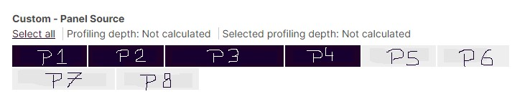

### **Fig. 6.5 Profiling depth**

**Fig. 6.4 Depth**

When multiple profiling questions are selected feasibility will decrease. The

reason is that by selecting multiple profiling question the sample pool is being narrowed to include only the respondents who fit all the specified criteria. Another factor at play is the profiling depth of each of the selected questions also narrows down the available sample pool.

Profiling depth, show in blue above the question answer options, shows what

percentage of all panelists have given any answer to that question.

Once an answer option within a question is selected above the answer options in the right corner PM Tool will display the profiling depth of the selection. This percentage shows what % of all panelists who have answered that profiling question, have given that specific answer.

### Panel Quality

In order to ensure we provide sample of the required quality levels we have agreed to always follow certain profiling selections when using KSolves-owned sample.

For all work done on our USA panels we need to ensure we select the following codes from the Verity variable. Verity can be found in our panel specific profiling points under the Research grouping.

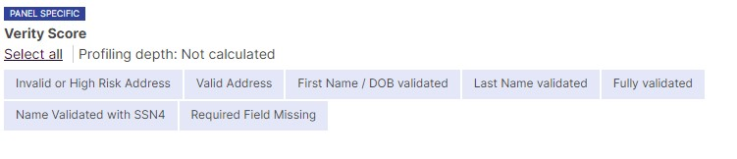

**Fig. 6.6 Variety Score**

#### **Fig. 6.5 Variety score**

Next to this, for all other countries we need to exclude our high completers from our sample pulls. High completers are panelists who have completed over 30 completes in the past month.

To exclude these, we need to again go to Research in our panel specific

profiling points and we need to select ‗LOW‘ from the Complete Level variable. This should be done for every job!

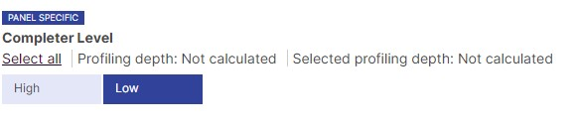

**Fig. 6.7 Complete Level**

### **6.4 Quotas**

By default, gender and age are the variables you can find here to input quotas

on. If you selected a region it will also show here.

Setting quotas means that we define a split among the different answer codes

of the variable selected. This means that once we start sending out sample later on, we will be trying to achieve this balance in our achieved completes.

If specific quotas are needed the defining bands need to be created at the setup stage, numbers within the band can be adjusted if needed once the project is created.

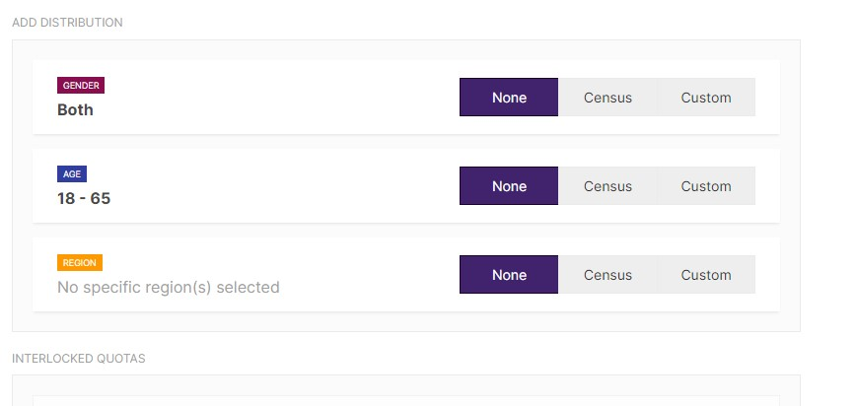

**Fig. 6.8 Quotas**

To define quota inputs you can select one of the below methods per variable:

6.4.1 **None**: if you don‘t have any balancing requirements. Example: you‘re only looking for male and have specified it already in the Basic Settings section.

6.4.2 **Census**: the system will provide a census representation for the selected quota. This census data is based on statistics collected by the UN and is updated regularly As KSolves best practice we should still follow our own source and add the KSolves approved census numbers form: **National proportion calculator 10 05 2016.xlsx** file via the custom option.

6.4.3 **Custom**: you‘ll be able to adjust the needed completes according to the project specifications by entering values in the wanted column.

You can either set-up the quotas per number of completes needed or a

percentage by switching on ―Set up quotas in %‖. By default, it‘s by number of completes needed.

If you switched to percentages, it can occur that you get a message that your

summed total does not add up to a hundred percent. In this case, switch to number of completes and ensure the sum matches the total number of completes you are after in the target group.

When working on the percentages settings sometimes the feasible column will show percentages above 100%, for example for males 300% and 500% for females. This simply means that the system can deliver 3 times (300%) and 5 times (500%) more completes than needed in those quota groups.

You cannot have all quotas be set to ‗None‘. In case you do not have any specific quota needs, you can set up your age quotas to reflect the total age universe of your target group.

Next to the age, gender and region quotas we can also set quotas on any profiling points we have selected. For profiling points, we will not have any census data available.

### 6.5 Interlocks

You can interlock two quotas by dragging a variable you want to interlock on top of a second variable. You can interlock any of the basic quotas or the profiling quotas. Attention, if you chose to interlock a basic variable with the profiling variable, it will interlock with all the profiling variables. There is no option to interlock a basic variable with only one selected profiling variable.

Once you created an interlocked variable you can set the needed completes for each break by typing into the wanted column and the system will let you know the feasibility, as like any other variable.

**6.5.1 Determining inputs for quotas on code groups**

When we are working with custom quotas, we are sometimes looking to achieve quota targets set to a less granular level than available in our variable answer codes.

For example, in our system social economic level can only be selected in very granular brackets, while we are often looking for example to achieve a certain split between groupings of answer codes .

**6.5.2 NEVER use an equal split across the wanted column.**

In order to set up our project in a way that maximizes our capacity and has the least bias as possible, we manually calculate an input number for each of the more granular ―wanted‖ cells based on the panel feasibility and the number of completes we want in the grouped answer codes .

Example (based on below screenshot):

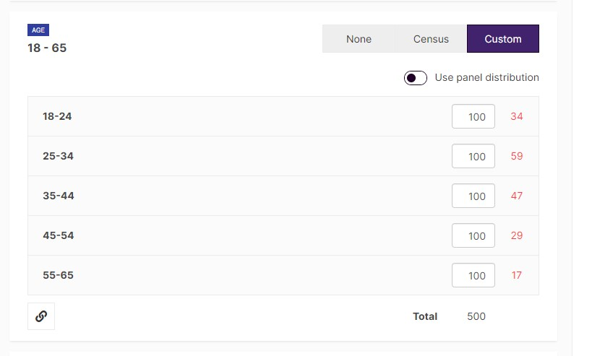

**Fig. 6.9 Interlocks**

**Apply RIM weighting to your quotas (balanced sampling)**

To make better use of our panel capacity (as well as not to create non existing

quota combinations) we will want to apply RIM weighting to the quotas we set up for our target groups.

By default, PM Tool will use NON balanced approach and create interlocked

cells to select panelists when sampling (even when we are not using interlocked quotas in the inputs). It creates underlying quota cells by having a simple variable cross with the other variable. It will then select for each created cell the panelists who qualify for all those dimensions:

As a result

* we might be biasing our sample pulls.
* potentially we are not meeting the interlocked quota requirement while we have enough capacity on our panel.

Therefore, we should always apply RIM weighting, unless the job used to run with more than 50% of its wanted completes being sourced through our legacy NSMX .

RIM weighting is applied by simply checking the tick box shown below.

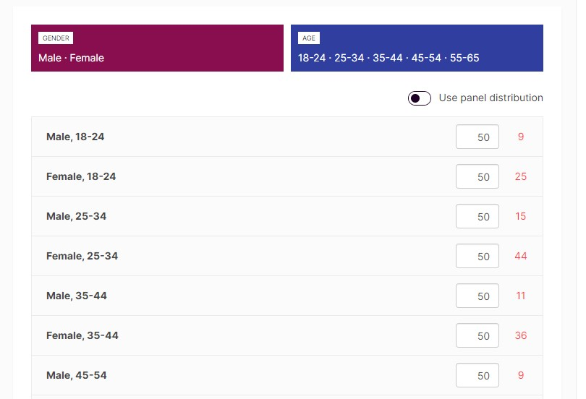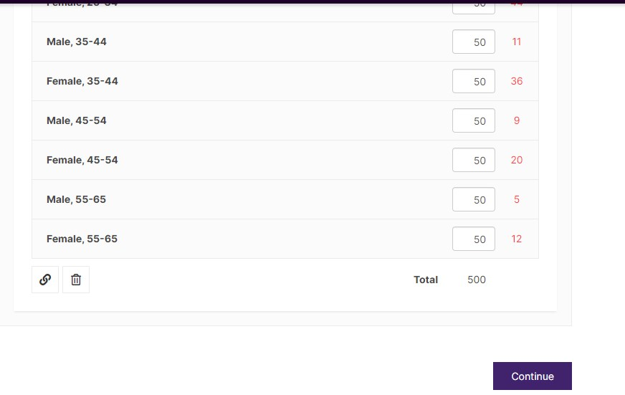

#### **Fig. 6.9 Set Quotas**

With RIM weighting applied the interlocked quota values are in proportion to

the universe (available panellists that meet any quotas set). The algorithm adjusts these numbers iteratively to converge towards target quotas set on all dimensions (the inputs).

The interlocked quota values become an output of the balancing process, instead of just being predetermined based on our inputs.

You can check the created interlocked cells by clicking on ‗Download sub-quotas (CSV)‘.

### **6.6 Exclusions**

For each target group we can exclude panelists from previous projects. We

have several tools available to use in order to implement such exclusions.

#### **6.6.1 Automatic Exclusions**

Each target group will by default not allow any panelists already sampled in any of target groups of the PM Tool Project to be sampled on again. The only way to circumvent this limitation is to select the ‗Specific Panelists‘-option from the Supply tab (see ‗Supply‘). Panelists selected in this way, will be allowed to be sampled on again.

In addition to this, all panelists trying to enter any target group in the same project will have to pass the Relevant ID (digital fingerprint) checks on geolocation, duplication and quality standards. All panelists with a status other than ‗timed out‘ in the Project (not just the target group) will be prevented from entering again.

If for whatever reason, you do need to have panelists with a particular status to re- enter (for example, you are conducting a recall) then you would need to set Prevent Duplicates to NO on the Project Overview screen (see Creation of a Draft).

#### **6.6.2 Project Exclusions**

On the Projects tab all projects available for exclusion inclusive of project name and start date are shown. The tab contains a search box where projects can be searched. This will search by name only. One cannot enter a Project ID here in order to find a project.

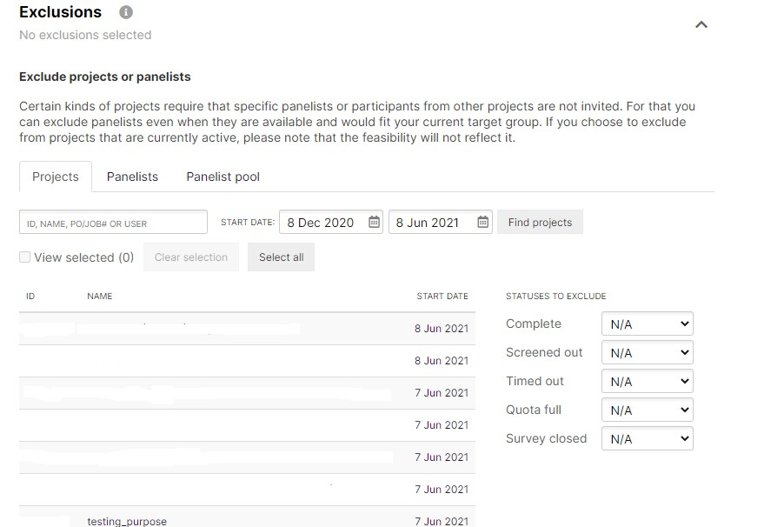

##### **Fig. 6.10 Exclusion**

On the right-hand side across the project name and start date can be found all

statuses that can be excluded.

Please note that one or multiple statuses can be selected, however it is not

possible to exclude different statuses from different projects. For example, to exclude only completes from projects 1 & 2 and from survey 3 to exclude only those who ended up as a quota full in that project.

If such combinations are needed, we would need to export the IDs to be

excluded and use the Panelist Exclusions.

After you have pasted the IDs and clicked ‗Import‘ you will see a confirmation on screen of how many IDs were successfully loaded for exclusion.

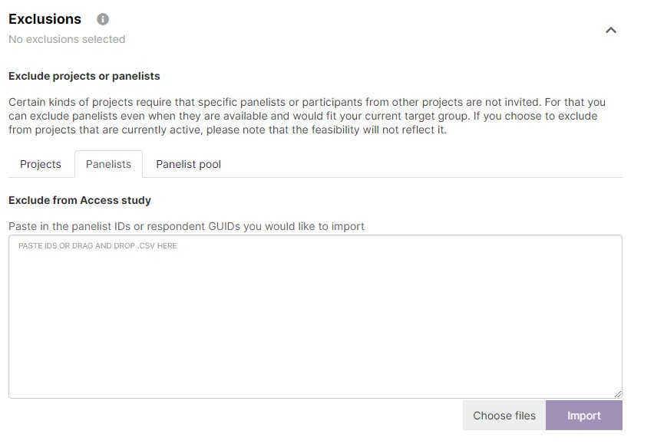

##### **Fig. 6.11 Panelist Exclusions**

We can combine usage of Project Exclusions and Panelist Exclusions.

Once exclusions are set for the target group, it is not possible to adjust them

later once the project has been created. In those cases, a new target group would need to be set up with the new exclusions set up.

### **6.7 Naming of TGs**

**Duplicate** – when selected PM Tool will create and identical copy of the target group as an additional target group. If no name is given to the initial target group, the new one will automatically be named ―Target Group 2‖ by the system.

Please note that this function is only available when a project is still a draft. Also, when you duplicate a target group and subsequently change the country to survey, any profiling and region information will be lost.

**Rename** – this button allows the user to name the target group as they choose to, giving specific names to the target group(s) or countries in case each target group represents different country.

**CHAPTER 7**

### **Creating a Project**

Once a project has been commissioned, the created draft needs to be converted into a Project. This will lock down our supply sources, exclusions and quotas and will allow us to prepare our target groups for the start of fieldwork.

Because some of the features of a draft will be locked down once we create a project, we will need to review the draft versus the final commissioned specs at this moment of the process and make any edits needed.

Once the project setup is created, the audience has been defined profiling selections, quotas and exclusions (if applicable) have been specified, the user needs to select the ―Create Project‖ button in order to create the project and convert the project into a sampling setup**.**



#### **Fig. 7.1 create project icon**

Upon clicking this button, a **Summary page** containing specific survey information like project details, redirects and Terms and Conditions will be shown. This page requires input on further project details before being allowed to continue.

All information listed below much be added and confirmed by clicking ‗run

project‘ within one hour to avoid session time out.

**Project name** – this needs to include the (main) Maconomy number and the full name of the project; we suggest adding country name(s) or abbreviation(s); if it‘s part of multi wave project, always add wave number/dip name, so it can be easily found in project list for exclusion or any other task.

**PO** – purchase order **must** contain the Main Maconomy number for all projects

**Job Number** – internal Job number, which will be shown in the invoice KSolves will receive from PM Tool

**Contact name** – Full name of a person creating the order.

If other supply sources than KSolves panels are used then a two-letter country abbreviation of the commissioning country needs to be added here, in order for the correct PM Tool CS team to pick up the project and assist us. If no country abbreviation is added, the PM Tool CS team will reach out to the contact email (see below) and ask for this information. Example: Adam Smith [UK]

**Contact email** – email address, by which PM Tool team can get in touch once order is created to send approval confirmation and provide support on a project level. The email address entered here is also the email address any system alerts will be send to. This is not editable later.

### 7.1 PM Tool Terms and Conditions

These need to be checked on every project.

#### **7.7.1 Splitting a job over multiple PM Tool projects**

When you are managing a large multi-country job, or have to use lots of target groups within one project, you can choose to split up a job over multiple PM Tool project. This helps to stay within the limit of 50 target groups per project and can improve the ease of fieldwork management.

When this is done, it is important to mark all the PM Tool projects with the same main Maconomy number, both in the naming convention used and in the PO and job number fields.

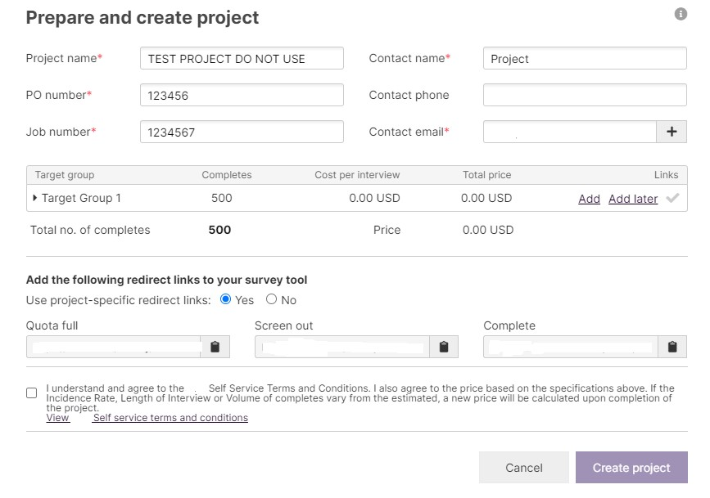

**Fig. 7.2 Summary**

Adding in Survey Links

At this point we can add the survey links for our target groups. Each target group needs to have a survey link before fieldwork on that target can be started.

If the survey links are not ready yet at this stage of the process, users can select ‗Add Later‘ and continue.

If ‗Add Links‘ is clicked the survey link interface is opened.

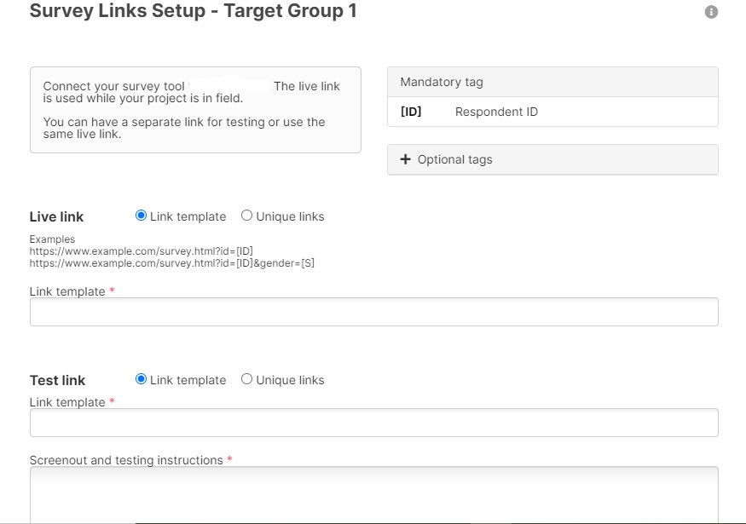

##### **Fig. 7.3 Survey link setup**

On this page we have two options for setting up a survey link:

1. One generic link, which is set up per project

1. Unique links for respondents

As a default we will set up a generic link whenever possible. In this case the ―link

template‖ field should be selected (this is also the default setting).

**Generic Links**

The generic link can be used for all of the respondents, and it should be

provided by the client in the following format: https://www.example.com/survey.html?XXXX

In order for PM Tool to track respondents, a unique respondent identifier is automatically generated and appended to every live link. The system knows where to place the respondent identifier in the link by the tag [ID] that is inserted in the link. This ID is commonly referred to as the GUID or code, which contains 36 digits, numbers and letters. **Please note**, use ID=[ID] alias (in capitals), not id=[ID] as shown in PM Tool examples, as this will cause conflict in Ksolves India Limited!

The GUID ID is a unique identifier for each respondent and it is generated per project. The GUID or code identifies what survey the respondent participated in and what status they received when they return to the system. It then allows the system to automatically credit incentives to respondents with status ―complete‖ based on the incentive models used for each panel.

### **7.2 Optional tags**

In addition to the [ID] tag, PM Tool allows us to use several other tags to pass

in information dynamically through the survey link.

The optional tags that can be added in the link are:

7.2.1 Gender – [S] – the outcome would be: 1- male, 2 - female

7.2.2 Year of Birth – [YOB] – year of birth i.e. 1988 will be passed through the survey link

7.2.3 Date of Birth – [DOB] – date of birth i.e. 01/02/1988 will be passed through the survey link

7.2.4 Age – [AGE] – the actual age of the panelists i.e. 30 will be passed through the survey link

7.2.5 Post Code – [PC] – full post code (except UK, where only first part of postal code is shared)

7.2.6 Panelist ID – [P] – unique identifier in PM Tool system per panelist (numeric).

**This is considered PII.**

7.2.7 Member ID – [M] – unique identifier from the legacy platforms – PM Tool.

**This is considered PII.**

Note that the tag used, does not need to be the parameter name. For example, we could add gender in any of the below formats:

### **7.3 Panel Questions And Answers tags**

In addition, we have the option to pass through our panel specific panel

questions via special tags specific to our panels.

These will be always starting with PQ and then a numeric panel question ID (example: [PQ148588] or [PQ82u323]). The values passed through the survey link for these tags will be the answer code IDs from our database, **NOT** the codes or labels.

Example: householdincome=[PQ8hhdj]

These panel question IDs and the corresponding answer code IDs are stored in Engage, our panel management system. The same panel question can have a different panel question ID in different countries, so this needs to be verified before use.

at the moment all the PQ variables are stored in an excel file, within our Teams folder:

…\SharePoint\XYZ - One Platform - Early Ado - Doc\General\06_Training Materials\02_XYZ Final Document

What the client will get passed back is the PQA code from column G.

### **7.4 Non-dynamic parameters**

In addition to dynamic tags we can also add any parameters on to the URL that are not dynamic. These parameters will be set to a common value for all panelists sent through the survey link.

Examples: Batchno=1 or Batchno=5001

One of the non-dynamic parameters we will need to **always** enter on the link

is ‗table‘. Without this variable, the respondent will be unable to return properly to the PM Tool system after completion and we won‘t be able to follow the progress on the preview page and the panelist will not receive any incentive.

The value of the ―table‖ variable is always static and it will be the Project Token value from the redirect links. The redirects are displayed on the Summary page.

### **7.5 Test link and instructions**

When partners are involved in our project, they will need to test the survey before

launching sample. The survey link we paste into the test link field will be used for this.

On this link we will need to add any test parameters (example: i.test=1)

#### **7.5.1 Screening information**

To ensure quick test results, it is very helpful to have either screening

questions or criteria to complete the survey more efficiently stated in the notes.

**Note:** We do not have in-system templates for survey link set ups. So we need to be very clear in our communication with scripters on which parameters need to be added for each project. For our work with KSolves we have agreed the parameters we will need to use (see KSolves URLs)

Unique LinksIn order to use unique links instead of a generic link, change to

radio button from link template to unique links.

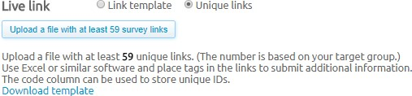

**Fig. 7.4 Live links**

You will now be able to download the template file which shows you the format in which the links need to be uploaded to the system. You have to upload at least the number of unique links suggested by Access, a couple of links for testing and any important information about your project.

It is important to not remove the first 3 rows of this template file. Copy the required number of survey links from your survey tool and paste them in the file, first link in row 4 column A (one link per row).

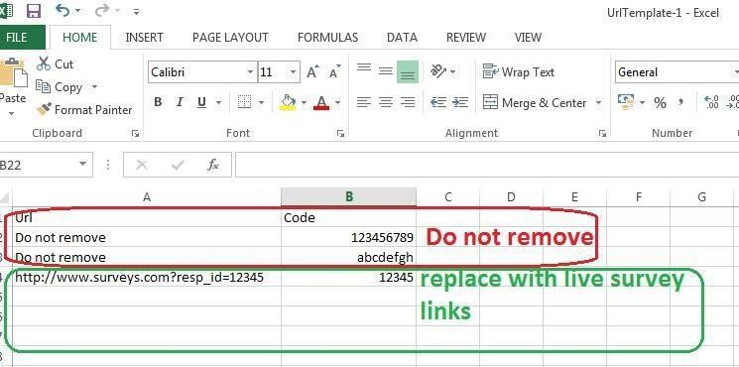

**Fig. 7.5links for testing and any important information about your project.**

Once the links have been copied into the file, save the file to your computer and make sure that it is saved as a .csv format. Upload the file to Access by clicking on

―Upload a file with at least XXX links‖ (see screenshot above)

A couple of unique test survey links should be added in the ‗test link‘ section alongside with other information that is important for Access to know. **Make sure not to include any test links in the live links file.**

As long as the project is still active you have chance to upload more survey links and next invitations will be sent using the new one. The system will notify you when the target group is running low on uploaded survey links, and how many it recommends that you upload.

The unique links uploaded will form a pool of links and will be used by respondents on a first come, first serve basis. We cannot specify which link needs to be assigned to which respondent.

However if we do need to do this, we will need to reach out to the PM Tool Customer Success team via a ticket in Zen desk. But any future send outs will need to be done by the PM Tool team as well, to properly tie unique links to IDs. So the PM Tool team needs also the send out schedule – for invites and reminders.

#### **7.5.2 Testing a survey**

The testing process is not an end to end test, we do not have TEST IDs or see

any movement in the preview page of the project.

When testing we will be going straight into the scripting platform using a fake entry link. You cannot enter through the PM Tool platform/portal. You need just to copy/paste it in a web browser and test it until you see the proper end page, then please make note of the fake IDs you‘re using and send them to the scripting team/client for removal.

To check if the client/scripting team have implemented the redirects correctly you have to make sure that once you finish the survey and land on the PM TOOL redirect pages you‘re passing back, a status, Id and Project Token.

You can check the status on the landing page

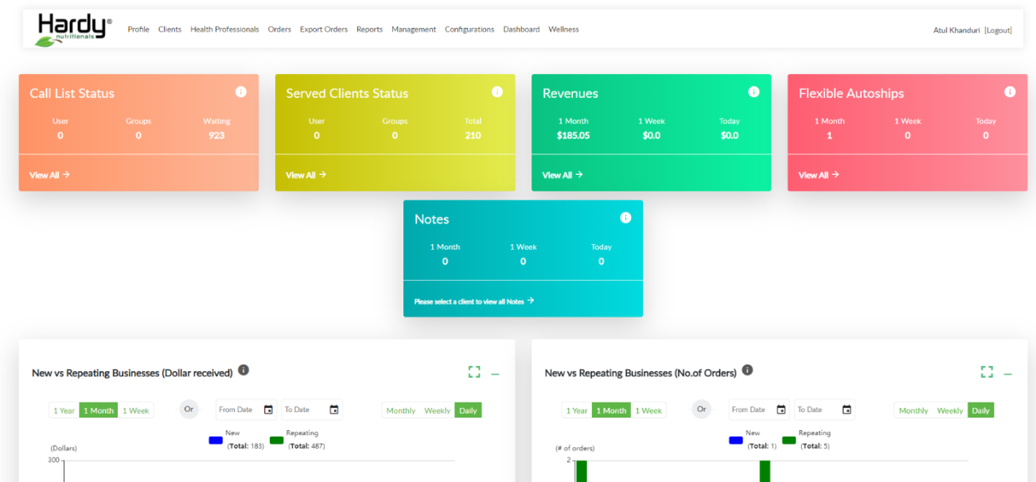

**Fig. 7.6 Project Admin Dashboard**

You will always land on the following PM Tool branded page. This does not indicate any issue.

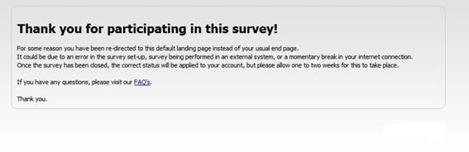

**Fig 7.8 The redirects displayed will be for Quota Full, Screen out and Complete.**

### 7.6 Redirects

When we create a new project we will as a default be presented with project

specific redirects on the Project Overview page.

#### **7.6.1 Redirects for external Sample Only clients**

For external sample only clients we have created a document, describing the

process for them to implement redirects for One Platform in their system.

This document should be shared with them as soon as our Project Managers

contact the clients.

The redirects in the document deviate from the default redirects in a couple of ways:

7.6.1.1 The domain in the redirect link is replaced by the domain. This ensures our external clients do not get confused about the source of their sample, as we hide the reference to PM Tool in our technical set up.

7.6.1.2 We will be asking our clients to pick up a value from our entry URL

called ―table‖. This value will be passed back in the end redirect as ―Project Token‖, making the redirect dynamic and re-useable.

7.6.1.3 We provide a fourth type of redirect to be implemented for Quality

Fails (like Speeders or people who fail Trap Questions)

An example of the redirects we will provide:

Completed: https://NsMatrix.com/Survey/Complete?ProjectToken=${table}

Screened:

https://NsMatrix.com/Survey/EarlyScreenOut?ProjectToken=${table}

Over Quota: https://NsMatrix.com/Survey/QuotaFull?ProjectToken=${table}

Quality Fail:

https://NsMatrix.com/Survey/Finished?ProjectToken=${table}

When we set up our survey URL (see ‗Add study link‘) we need to ensure we

include the value of the project token (which is part of the default generated redirects in the system) and hardcode it behind a table parameter.

Example of what we would need to add:

&table=3786589b-djhd-uwhd-6863-bdhbd7882h3

#### **7.6.2 Redirects for Hardy Nutritionals and Internally Scripted clients**

For jobs using the Hardy Nutritionals PM Tool-Aware template in Dimensions and for jobs scripted on our own Hardy Nutritionals platform, we will be relying on an API connection between these interview systems and the PM Tool platform.

This means that we will not need to send redirects on a project by project basis for these projects.

We would still select the project specific redirects for such jobs, for added

security. ―Run project‖ When all details are checked and above steps completed, ‗run project‘ button can be clicked to be redirected to project overview.

**CHAPTER 8**

**Project Delivery**

### **8.1 PM Tool Data**

Once a project is created, ‗PM Tool data‘ can be edited in order to ensure the correct data is provided to the KSolves portal in order to display the project in the correct way to panelists sampled for it. All values will have most common settings as their defaults.

**Survey Type -** This information will be used to determine where on the portal a survey will be displayed. A KSolves PM can assign one of the below values below to identify what type of research is covered by the project. ‗Other‘ will be selected by default description.

**Restart status** - This information will be used to determine if a study still needs to be displayed after a panelist has already entered it once before. A KSolves PM can indicate if restarts are allowed or not on a project. ‗Allowed‘ will be selected by default.

**Revenue status** – This information will be used to determine of a study is revenue generating or not. Revenue generating studies are prioritized above other jobs. ‗Revenue‘ will be selected by default.

**HD Type required** – This information will be used to determine if HD questions need to be asked and if so, which set of questions are to be used. ‗Consumer HD required‘ will be selected by default.

**Survey Display Text** – This information will be used to customize the text displayed on our portal to the project type or audience we want to survey. This is not a free text field and a selection can only be made from the below options. ‗Other‘ will be selected by default.

### **8.2 Project Management and Monitoring**

The Project Management and Monitoring page is used to control fieldwork for the project. It can be accessed via the button at the top of the Project Overview page.

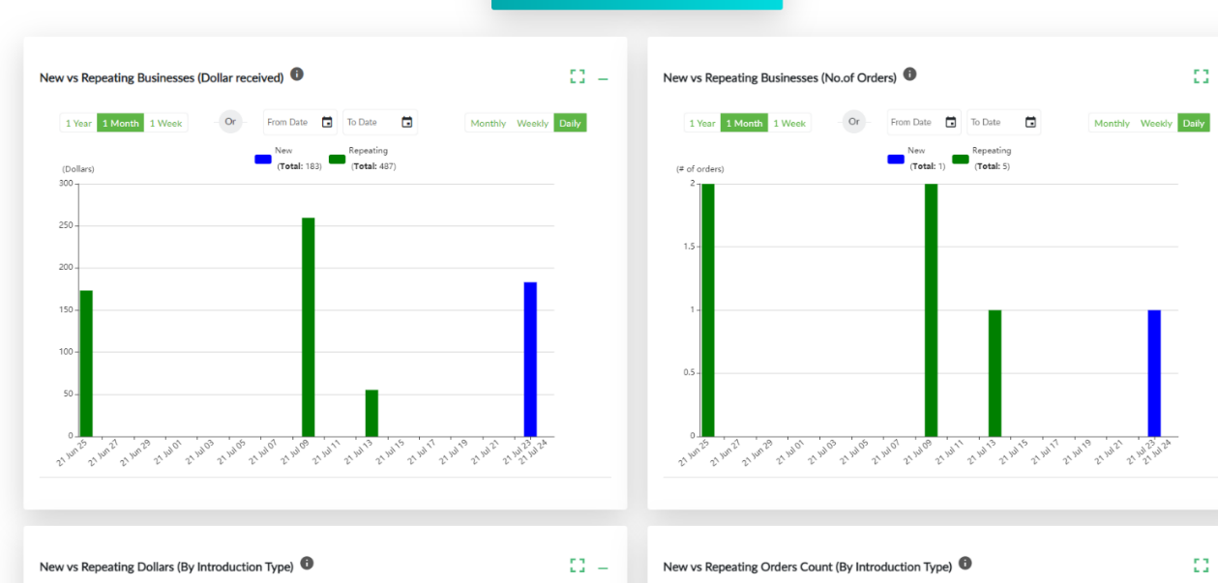

**Fig. 8.1 Project overview**

The management and monitoring page contains project name, primary owner (linked to the login of the creator – not the contact name), basic order specs like number of completes and progress, date and timings alongside with the status of the project.

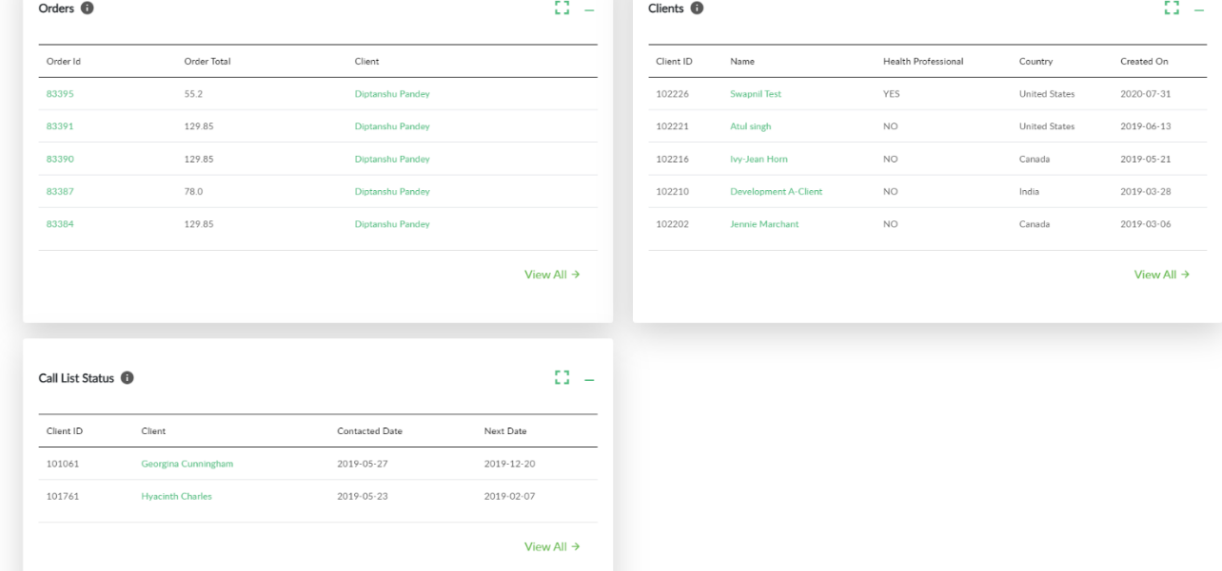

**Fig. 8.2 Project Management and Monitoring**

It will also display all created target groups, alongside the number of wanted

and achieved completes.

**Building in flexibility in your quota cells-**By default, the displayed number of wanted completes per quota cell displayed will act as hard stops during fieldwork. If we want 10 completes, then once we have achieved 10 completes no panelists will be allowed into the survey for this quota cell anymore, Optimizer will not send any sample to this quota cell anymore and on any future sample pull, no panelists for this quota cell will be sampled anymore.

Note: that any panelists who are in the survey will be allowed to complete, even if this means we go over the wanted number of completes

Sometimes we want to build in some flexibility into our quotas. We can then

up the number of wanted completes for a variable (maintaining the balance between the different quotas within the variable). **It is important to always have at least one quota set up which actually adds up to the number of wanted completes in order to prevent over completion.**

Example: We want to achieve 100 completes. They need to be 50 males and 50 females. On top of that we would like to have a rough balance of 50% of them being highly tenured and 50% being lowered tenured.

We would initially have to set up 50 wanted in each of the two tenure groups. As soon as we create the project though, we can now up the number of wanted to for example 100 in each group.

This will allow us to achieve more completes than 50 in either of the two tenure groups, while still telling the system to pull sample in a roughly balanced manner.

A softer way to include some flexibility is to set Auto Close to NO for a quota. This will not enforce the hard stops on this quota. It will however prevent more panelists to be sampled from this quota if the number of wanted is achieved. Auto Close will automatically be turned to ON if Optimizer is used.

### **8.3 Managing Tenure**

**We need to write this chapter!**

**Subquotas and relaxation (balanced sampling)**

If quotas were set up using RIM weighting, this means that within each quota we now have a complex grid of nested quotas (called subquotas).

Although they are balanced to optimize use of our panels, when we progress through fieldwork these subquotas can start to close. They act as quota stops and we need to manage them – if fieldwork stops, or becomes slow.

To review your subquotas (usually towards the end of fieldwork) and the completion in each of them, select ‗show subquotas‘ on the quota you are interested in.

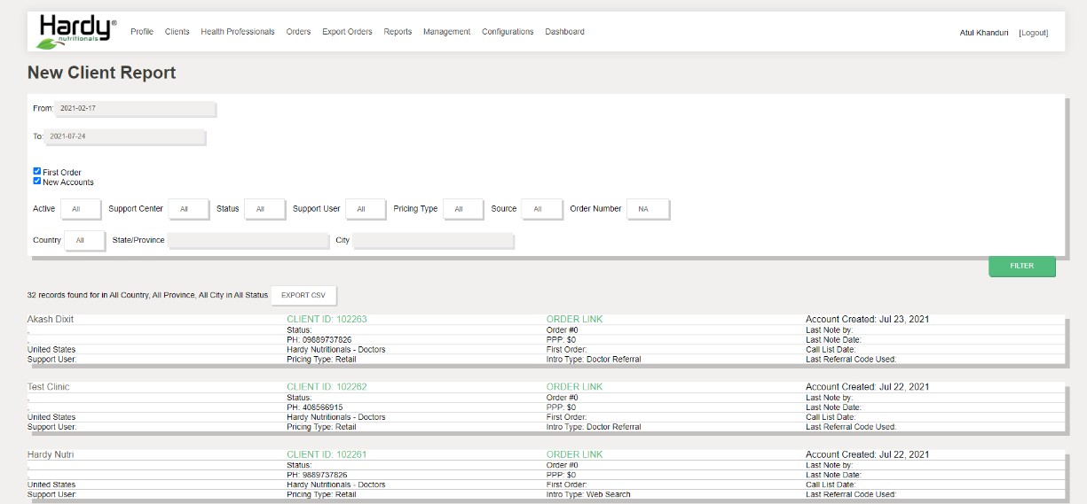

**Fig. 8.3 This will open up a grid displaying all subquotas and their achievement.**

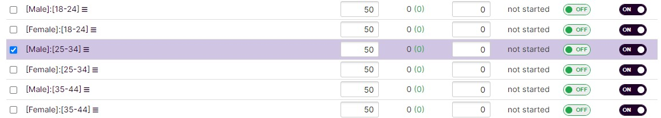

**Fig 8.4 If progression slows down, you can select the subquotas that have been filled and increase the size by a percentage by selecting „Relax selected sub-quotas‟ under Actions**.

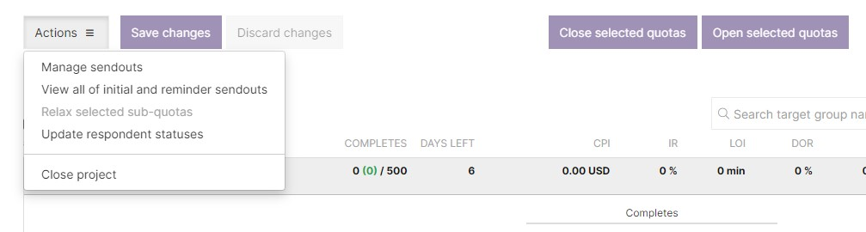

**Fig. 8.5 Select Relax Sub-Quotas**

Please note: that the relaxation is by a percentage. As a default it is set up to 5%, if you for example only need 1 complete in a cell, then relaxing that quota by 5% will result in allowing 1.05 completes. It is therefore fairly likely you will need to open subquotas by 100% or more, in order to actually create space to allow in more respondents. 1 becomes 2, if you open the quota by 100%.

When relaxing your subquotas, you will also have the option to ‗Remove

restrictions from the selected sub-quotas‘. This will allow any panelist who fit your open targets to come into the survey and complete. **Be aware though, that clicking this, will remove any balancing on your sample pull and therefore should only be used when in the last 10% of your fieldwork.**

### 8.4 Starting Rails

To start sending invites, click on the target group name and on ―Collect Completes‖. Prior to Soft Launch the client should have signed off on the links to be soft

launched in writing (email). Once received the PM may proceed with soft launching the study.

To sample from among the whole target group, use the target group's menu

(no.1 in the screenshot below). Selecting ‗Collect Completes‘ at target group level would sample in all active quotas, in accordance with their remaining wanted completes per cell, based on the amount of completes you sample for.

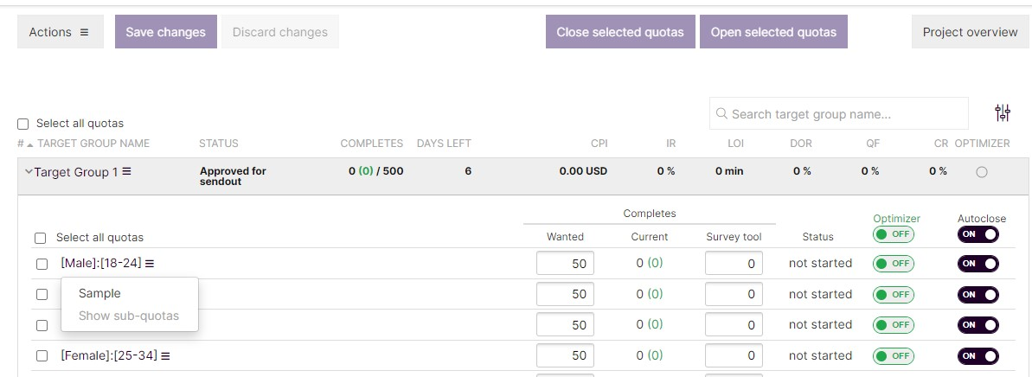

**Fig. 8.6 Sample Setting**

To sample in a specific quota, expand the target group by pressing arrow to the left of its name, then use the quota's menu (no.3). Expand the target group by pressing arrow to the left of its name, then send sample (or put optimizer on) for a specific quota only.

Note: that if you send out only on 18-24 year olds, you will automatically also send out to all linked quota cells (such as for example all genders, all regions etc.). If you want to send out only to 18-24-year-old males, you would have to close the female quota group before your send out. You can close and open any quotas by ticking the box on the left side of the quota and using the buttons at the top of the page.

After your send out you can immediately re-open the quotas again.

When using Optimizer (see Optimizer), sometimes you might want to achieve a number of completes lower than the wanted completes in a cell. In order to achieve this, you can change the number of ‗Survey tool completes‘.

Example from the screenshot above: we want 73 completes, we have achieved 17 completes. Optimizer is on. This would mean the system would try to achieve the missing

56 completes. If we change the number in the ‗Survey tool completes‘ to 50 for example, it would assume we miss only 23 completes (73 wanted, 50 achieved, so 23 missing). Using the survey tool column allows us to manipulate how many completes to achieve, without losing track of how many completes we originally wanted.

It is best practice to regularly update the survey tool column, in order to either determine how many future completes you need or to ensure PM Tool is in line with your actual survey tool.

### 8.5 Invitations

There are two ways to send invitations: Automatic and Manual. In order to

have more control over fieldwork we should choose Manual whenever possible.

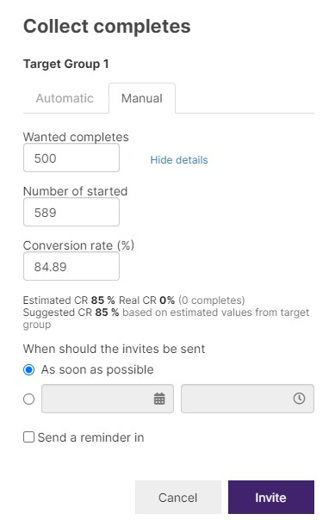

#### **Fig. 8.7 Collect Completes**

Note: When you select Automatic, this will let the system control when to do a send out and how often a send out is needed. It will also turn on the Optimizer (see Optimizer) automatically. The result is that the system will try to achieve all completes, with all methods possible in the least amount of time.

To do a soft launch (to make sure all completes are gathered correctly and also check the specs in field) select Manual and change the wanted completes to a lower number than the system shows by default (ideally 10-20% of the total wanted completes).

The system by default will send out as soon as possible. You can however also schedule your send out to go out on a later date and time.

As a default we also schedule a reminder to go out 2 days after your send out. You do not need to schedule this separately. **Note that reminders only go out to non- responders, not to incompletes.**

However, our Panel Policy on **NOT sending reminders** stays, so we should switch it off or jobs that aren‘t diaries, recontact etc.

Please note that when we send out invitations, this is the moment in the process that the system will go and sample the panellists it wants to send out. This may take a couple of minutes, so even when selecting as soon as possible, there might be a small waiting time.

Scheduled send outs can be cancelled by going to Manage Send outs. Past send outs can be reviewed for size and return by going to View all of initial and reminder send outs.

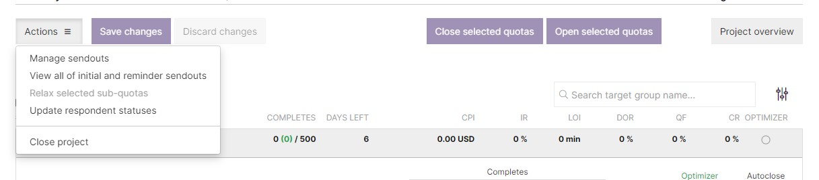

**Fig.8.8 Manage send outs**

#### **8.5.1 Customizing invitations**

If we a target group is using only one panel and it is a KSolves-owned panel, we can customize the content of the email invite going out by selecting ‗Edit invitation email‘ on the target group interface.

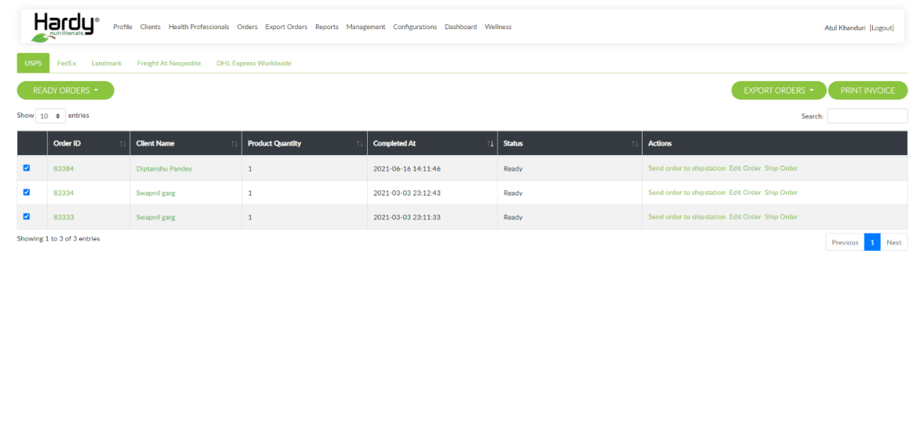

##### **Fig. 8.9 select edit invitation email**

This will open an editor where both email content and subject line can be changed. Changes will only affect the project you are working on.

Please keep in mind that we are following an invite-to-portal policy, so your invite will need to reflect this even after editing.

### **8.6 Optimizer**

Optimizer provides panelists additional opportunities to complete surveys, it displays the surveys that have Optimizer turned on, to those panelists who are currently active on the portal and have the relevant demographic characteristics.

These characteristics include not only their age, gender and region, but also any other selections set for the target group are taken into account, such as exclusions or profiling points.

Optimizer is not a Sampling Tool as it does not provide a random balanced sample, but routes panel traffic. Optimizer will fill quotas it is turned on for as soon as possible, and depending on traffic may generate a lot of completes in a short time frame.

If a quota is achieved then the project will disappear from the portal right away for any panellist in that quota cell, only if a panellist actually clicked on the link already will they be able to complete. Using Optimizer automatically turns on the Auto Close functionality, however due to portal traffic we might sometimes achieve a couple of completes more than wanted in a particular cell.

Because Optimizer is routed sample, we do not want to use Optimizer for all completes

For KSolves work, for example, we in general do not want to achieve more than an agreed percentage of our wanted completes via the Optimizer.

Please follow the standard LiveMatch guidelines. (paste them here?) In order to manage this, we have two options:

* We achieve 80% of our wanted completes via manual sampling, monitor completion through the Project Monitoring and at the end of fieldwork we turn on Optimizer.
* We create a second target group, where we define the number of wanted completes to be 20% of the total wanted number of completes. We then turn this on, at the same time as our main target group using manual sampling, which allows us to achieve in a shorter time frame than in method one.

Completes achieved via the Optimizer are displayed in green in the overview under the current completes column.

Note: that if you are using any ‗Push‘ suppliers in your target group, they will need to have Optimizer turned on in order to send traffic to your project. It is therefore recommended to have any ‗Push‘ vendors set up in a separate target group.

### **8.7 Closing fieldwork**

PM Tool has system alerts in place to let the project managers know when the specs of your study are outside of the minimum or maximum rules for each supply source. In AP, the system pauses sample as soon as some specific limits are exceeded.

Limits are defined for LOI, IR, Dropout Rate, Conversion Rate and Quota full value. The system will pause sample as soon as these values drop below the minimum or go above the maximum set values (see limits).

Note: that limits will not be applied by the system if we are using KSolves-owned panels or if we are using Ad Hoc supply. Please take this into account when selecting supply sources for projects where we expect metrics outside of the set limits.

When we see metric changes in field for our own panels, we should pause fieldwork by closing the quotas temporarily and investigating why metrics are out of bounds and potentially discuss revised costs before opening them again.

If, during project field work, your current study falls outside these rules, then Access will inform you and you will not be able to continue this project if the metrics won‘t improve. Possible actions you could take are defined in our trouble shooting documentation.

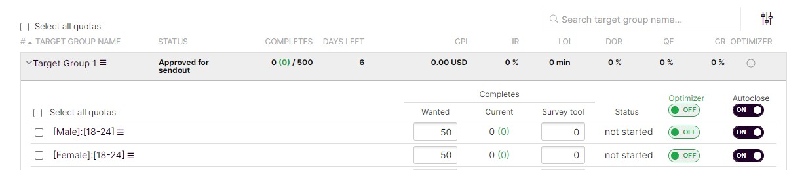

**Fig. 8.10 This is the message you will receive in “project management and monitoring”:**

The contact person (or more precise, the email address entered on the AP job) will receive email alerts in the event any shut down is triggered.

#### **8.7.1 Close Quotas**

Once all quotas are achieved, we should close the quotas to remove the project from our portal. This is done by selecting ‗Select all‘ on the Project Overview and the clicking ‗Close selected quotas‘ and ‗Save changes‘.

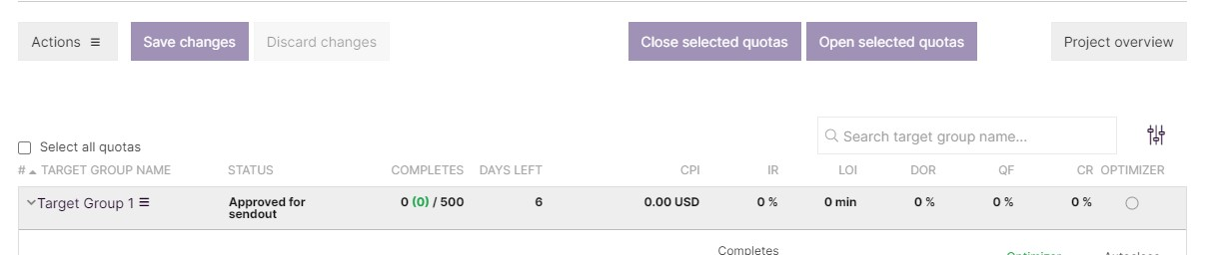

**Fig. 8.11 Close selected quotas and Save changes**

#### **8.7.2 Update respondent statuses**

Each PM Tool project must be completed by updating respondent statuses when fieldwork is finished. These are mandatory steps before closing the project in the platform.

If there's any discrepancy between your survey tool's respondent statistics and PM Tool then you have to update the respondent statuses at any point during fieldwork, so that we correctly reward respondents and panel owners, as well as monitor the quotas within PM Tool.

The data should be prepared in an Excel file in two columns, first column the URL/respondent code and second column the new respondent status. The respondent status has to be a number. 3 is an 'Early screen out', 5 is a 'Complete' and 6 is a 'Quota Full'. The list needs to be copy-pasted into PM Tool, separated by either a space, a comma or a semicolon. Do not use any other separators.

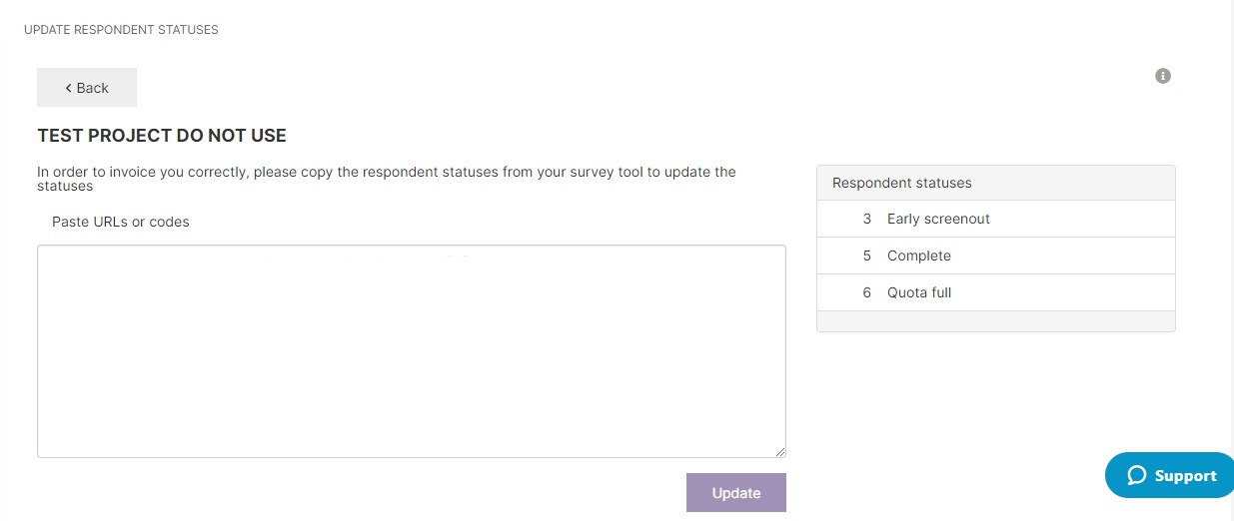

##### **Fig. 8.12 Update Responded Statement**

You can change a respondent‘s status to 'Complete', 'Early Screen out' and 'Quota Full', without being able to change 'Early Screen out' to any other status than 'Complete'. You cannot change respondent status of 'Complete' status cannot be updated to anything else without PM Tool assistance.

### **8.8 Closing Project**

You close a project from the project management and monitoring screen using

the ‗Close project‘ action:

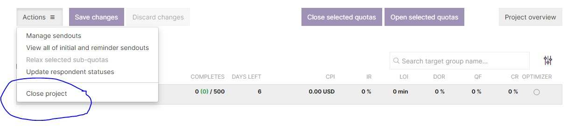

**Fig. 8.13 A project that is closed cannot be reopened.**

Make sure all needed steps/ tasks are done before you close a job in PM Tool:

* Final respondent statuses (including for partners) are updated/ IDs are uploaded.
* Your client has confirmed you can close the project (no additional completes are needed to be achieved).
* In case you used other sources than LifePoints panel you agree with the price with partners and they have confirmed metrics.

### **8.9 Download Background Data**

During and/or after fieldwork an export can be created from a project by

clicking on the ‗Download Background Data‘-button on the Project overview page.

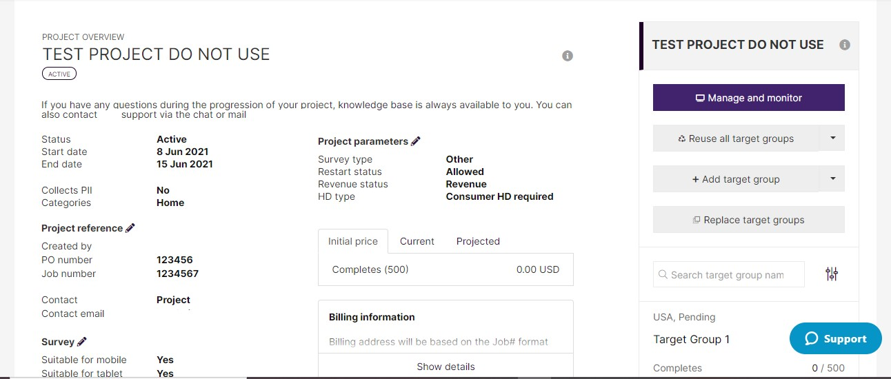

#### **Fig. 8.14 Download Background Data**

The file contains data on respondents that have interacted with the study in some way, thus the following respondent statuses are exported:

* Early screen out (status coded as 3, in the exported file)
* Started (status 1)
* Complete (status 5)
* Quota full (status 6)
* Timed out (status 9)
* Fraudulent (status 16) • Suspicious (status 11)
* Quality terminate (status 17)

The file will **NOT** contain the IDs and data of all the sampled panelists for a project, only for respondents with the above statuses. Data on non-responders can only be accessed by contacting the PM Tool CS team.

Attached to these IDs are a set of 42 pre-defined background variables. It is not possible to pick-and-choose which variables are included on a project level. For additional background data to be provided, we will have access to a stand-alone Data

**CHAPTER 9**

**Supply**

### **9.1 Usage of integrated partners as Ad Hoc supply**

We can choose to use an integrated partner (PM Tool Exchange or Private Pricing) as Ad Hoc supply.

We might select partner X from the Private Pricing on one project and due to the pros and cons of the different methods of integrating we might select them from Ad Hoc supply the next time.

Some reasons why we might use an integrated partner as an Ad Hoc partner instead:

* To bypass some of the system restrictions
* To give more control of fieldwork to our partners
* To maintain legacy eliminations
* To work with a non-rate carded price etc.

As a rule, whenever work has run previously with partners when we were still on our legacy systems, **these partners will now need to be used as Ad Hoc supply**, even if integrated. This in order to maintain sampling consistency and to ensure proper exclusions can be set.

### **9.2 Working with Ad Hoc supply**

When we want to use a partner via the Ad Hoc supply route, we need to ensure a setup is created for the partner in question. Setups are re-usable and it is important to only set up a new Ad Hoc supply setup if the partner in question does not yet exist. Most common partners used, should have an existing set up we can select. If no setup is present however, contact [xxxxxxxxxx?] to add. You will be required to include the redirects of the partner you need to set up in this request.

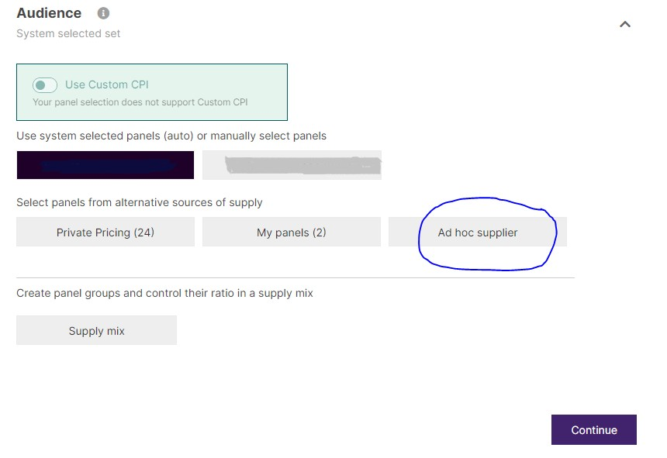

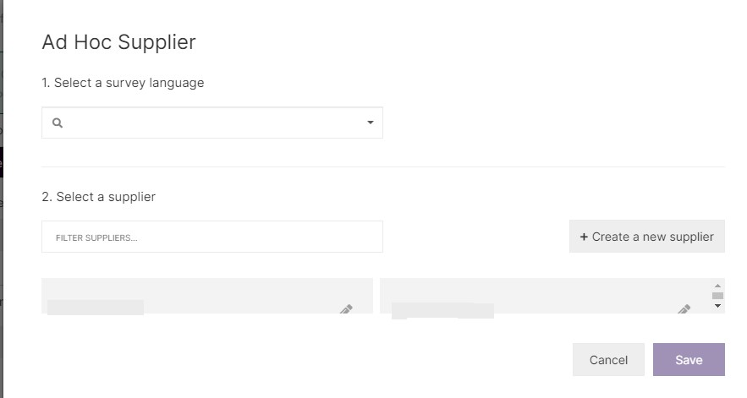

**Fig. 9.1 Select your supplier from the Ad Hoc supply set ups**

Please note: You can have only one Ad Hoc Supplier per target group.

Next, after converting your draft into a Project, ensure you have set up your

live and test links for the target group.

### **9.3 KSolves API project**

However, in case we are working with projects scripted by KSolves in the new PM Tool Aware scripts, there is some additional work to be done, in order for our partners to successfully test our setups.

In the Target Group Overview, click on ―Supplier Monitor Link‖.

Double-check the supplier redirects on the setup screen. Update them if needed before selecting ―Update Settings and Test‖. At least one of the attributes from the URL, must be set to change per respondent. This most likely is the attribute used to identify the unique respondent.

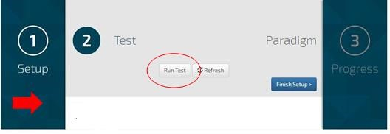

**Fig. 9.2 On the test screen (marked with the number 2), click “Run Test”**

A new browser tab will open called ―Survey Matcher‖. Close this tab and return to ―Supplier Monitor‖ Test page. A line item with a Date and Time stamp will appear – click on the arrow to open up details.

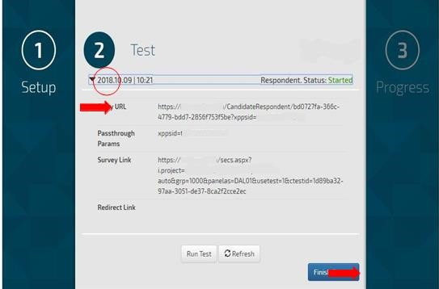

#### **Fig. 9.3 Grab “Entry URL” and remove the value attached to the supplier unique**

**respondent variable.**

This will be the test link you can send to your partner. Create as many test links

as needed by your partner (minimum of 5 URLs). Each link can only be used for one test.

Next click on ‗Finish Setup‘ and grab the live entry URL.

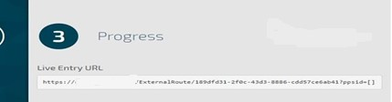

**Fig. 9.4 Pass the Test and Live links to the supplier.**

**CHAPTER 10**

### **Mainstream**

In PM Tool we will not have Mainstream as a source of panelists. Instead we are integrating some of the sources behind Mainstream into our Private Pricing.

Proposals will include which supply sources to use on our jobs and to what percentage.

However, for normative projects or trackers where we have been using Mainstream in the past, we need to ensure we continue providing panelists from the sources used previously (as Mainstream) in our new set ups to ensure data consistency.

Per country, analysis has been done about how in the past our Mainstream completes have been coming through with which spread from the different sources now integrated as Private Pricing. This has led us to determine a ‗Mainstream‘ sample mix to be used for each country on these projects.

Please reference the ‗Mainstream Sample mix by country‘ document for more details.

To collect completes only use **Optimizer**, only some providers are integrated in a way that allows manual sampling. Optimizer works for all.

In order to set up UK for example, you have to use Supply Mix, and set up quotas:

Prodege (Swag bucks in AP) = 45% P2Samnple = 20%

G (Clixsense, Dalia, Tap Research, Vindale) = rest, so 35% - actually, there is no way to group them (due to different rate cards, prices), therefore the G value needs to be spread equally among partners

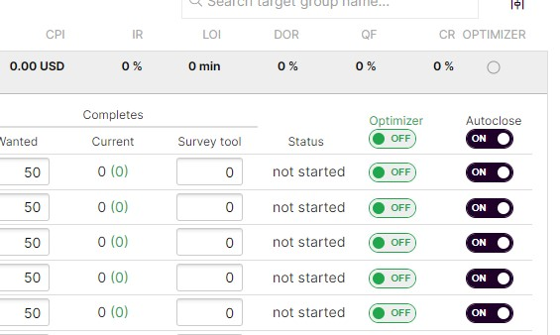

### **10.1 System Limits**

When we are using either the Exchange or our Private Pricing partners, there are safeguards in place to ensure panelists keep on flowing to all our projects in order to be converted into completes.

Currently the system will pause if:

* If the incidence rate (IR) drops under allowed country rules.
* If median Length of Interview (LOI) in field is greater than allowed country rules.
* If DOR rate is above 35%.
* If OQ rate is above 35%.
* If median LOI for screen out is above 3 min.
* If median LOI for OQ is above 3 min.

The most up to date country business rules can be found here: https://PM Tool.com/hc/en-us/articles/22269160

### **10.2 How to run: Trackers**

Trackers are projects were we need to collect data over a longer, continuous time period. Often within this longer fieldwork period a fixed number of completes will need to be achieved on a smaller basis, usually the delivery is split into quarterly/monthly/weekly rounds.

Each round should be set up as a separate Project (although you can usually

combine 4 weekly rounds into one Project without too many negative side-effects).

As usual Target Groups can be used within a job to set up specific panel

partners/mainstream, or specific targets such as main/boost etc.

It is very important to follow the naming conventions on trackers (see Eliminations section below). The **main** Maconomy number needs to be used in the Project name and set as PO and job number.

### **10.3 Creation of Waves**

To ensure we are as consistent as possible in our set up and sampling between waves, we recommend that after running the first wave you click on the ‗Reuse all target groups‘-button of that job. This will create a copy of that job for you. Rename it accordingly.

It is important to note, that although the copied project copies over a lot of

information, there still are some areas that need manual updating each wave:

1. Updating your project name with a new wave/round indicator
2. Setting up the URL per target group – the URL does not get copied over.
3. Set up your eliminations – Eliminations need to be set up each round and per target group. Please also note that you need to select the correct projects to eliminate (e.g. compared to the last wave now remove those who fall out of the lockout period and include the last wave).

#### **10.3.1 Eliminations**

Each wave eliminations need to be set up again. It is important to know which previous PM Tool Projects are part of your tracker AND when they ran. This is why both Maconomy number and wave/round indicator are part of our naming convention.

#### **10.3.2 IDs**

When running trackers, note that we will now be delivering project specific IDs (GUIDs) to the scripts. These IDs are not the same across waves for the same respondents. Therefore, there is no longer any need for ID-resetting.

When a client sends back IDs to match data, deliver additional background

data or to exclude/include these will be the project specific GUIDs.

PM Tool will recognize GUIDs for eliminations, sample selections etc. However, if you need to add background variables or such to them, you will first need to convert them to the PM Tool ID.

If you export the background data from a project, using the ‗Background Data‘- button from PM Tool, you will get both the GUID and the PM Tool ID in that file.

**Matching IDs-**

AP will create a new GUID for each respondent of the recontact. It means the GUID will be different between the main study and the recontact.

However, you will be able to match them using the Panellist ID from the

background data and provide the mapping to the client.

If your client insists on having the recontact done with the same identifier, then you will need to create a file of unique links, with the original GUID in there and link this to the PM Tool IDs. This file will then need to be sent to the PM Tool Customer Success time to send out.

**CHAPTER 11**

### **Note on PII collection**

Specific methodologies often require the collection of personal identifiable

information and therefore always need consent at recruitment stage.

If you have to collect PII information and share it with the client, then a NDA

will have to be raised and any respondent will have to be asked for their consent to share such information.

This will need to be included in the script and the consent has to explain:

Which PII information will be collected,

For which purpose,

Who will be able to access these information?

Please reach out to your local GDPR champion in case of any doubts.

### **11.1 Hardy Nutritonals Testing**

Make sure you don‘t leave i=testXXX in the live link, this will mess up your

completes, they will all be marked as 1 survey in KSolves and as multiple in PM Tool.

**Blend management on trackers post-cutover-** Once legacy projects move over to have a LifePoints quota bucket, we will still be expected to balance on the legacy source of our sample. However, we will then no longer be required to pass this information on to the scripts.

There will also no longer be quotas set on these in the script. The balancing will take place within PM Tool.

Over time we will be adjusting the blends within a project, to account for attrition among our legacy panelists. The process to establish initial blends.

**CHAPTER 12**

### **CONCLUSION**

Now a day‘s people who want to take admission want to know each and every thing about the college and university. For this the website is the easiest way to get information. And to attract students and visitors we require proper information and require to keep information updated on daily basis. But it is not an easy job to update information time to time as it requires proper maintenance which become very costly. So, with this website we are providing proper information in attractive form and most important is that to update content of website we don‘t require any expert just need credentials and anybody will able to update content either he/she is aware of coding language or not so there is no requirement to hire a specialist for maintenance that saves a lot of money. This website is more descriptive and containing full information about university and colleges.

### **REFERENCES**

1. Web Technologies by Peddi Kishor, Pages 11-25, 2018.

2. Object Oriented Analysis and Design, 2018.

3. Design Analysis and Algorithm, 2018.

4. Web Technologies and Application Springer, 2019.

5. Engineering Analysis & Optimization using CAD Software, 2014.

6. Software Engineering New Approach.,4 march 2019.

7. Web Technologies Using PHP and My SQL Ltd, 2018.

8. Understanding Data Communications and Networks: 1997-2014 (Vol. 1, No. 1-Vol. 18, No. 4).

9. Olivier Mesly, ―Introduction to Linux installation and Programming‖, 1st Edition 2017.

10. Ofer Zwikael, John R. Smyrk, ―Biostatics & Computer Application AG, 2019.

.11. A Textbook of Engineering Graphics: 25 Issue: 4.

12. [Rob Larsen ,](https://ebooks.wileyindia.com/searchresults?keyword&option=catalog_shelf&title&author=Rob%20Larsen&type=advanced) ―Beginning HTML and CSS‖ ,March 2013 .

13. Sayed Hadi Sadeghi, ―Logical Methods in Computer ScienceAG, 2018.

14. Jean-Francois Denault, Journal of Universal Computer Science‖, 19 September 2017.

15. Internet Research Issue(s) availiable:138 – form Volume: 1 Issue: 1, to Volume: